Innovation Drive and Technology Expo

Final Documentation

Chris Ciolek

Nicholas Spencer

Maxx Achtman

Apolonio Cazares

Acknowledgements:

This project could not have been completed without the help of all the professors at U of M Dearborn who guided us since the beginning of our college time here. Thank you to Professor Maxim and Professor Akingbehin for being the professors who have helped us throughout this project. Finally, thank you to Jamel Belwafa and Ford Motor Company for allowing us to help you and your team build this project that would be used for years to come.

Table of Contents:

**Introduction** **10**

Goals and Objectives 10

Software Context 11

Major Constraints 11

**Requirements** **11**

Functional Requirements 11

Non-Functional Requirements 12

Hardware Requirements 12

Software Requirements 12

Inverse Requirements 12

Deliverables 12

Inputs 12

Processing 12

Output 12

**Analysis Model** **13**

Class Diagram 13

Sequence Diagrams 14

Register a Technology 14

Register as Evaluator 14

Register as Supplier or Presenter 15

Send Email 15

Open or Close Event Registration 16

Edit or Delete Events 16

Check In Attendee 16

Add or Remove Technology Category 17

Add, Edit, or Remove Technology 18

Add, Edit, or Remove Attendee 18

Generate Badge Sheet 18

Pull Technology Database 19

Pull Attendee Database 20

**Hardware Design** **21**

Diagram 21

Explanation 21

**Software Design** **21**

Data Design 21

Internal Software Data Structure 22

Global Data Structure 22

Temporary Data Structure 22

Database Description 22

Architectural and Component-Level Design 23

Program Structure 23

Architectural Diagram 23

Description for UI 24

Processing Narrative for UI 24

UI Description 24

UI Open Webpage 24

UI Add User Registration 24

UI Add Technology Registration 25

UI Edit User Registration 25

UI Edit Technology Registration 26

UI Export Data to Excel 26

UI Change View of Webpage 26

UI Digital Waiver 27

Description for Logic 27

Processing Narrative for Logic 27

Logic Description 27

Logic for changing page 27

Logic for Registering User 28

Logic for Registering Technology 28

Logic for Changing User information 29

Logic for Changing Technology information 29

Logic for Exporting data to Excel 30

Description for Data 30

Processing narrative for Data 30

Data Interface Description 30

Adding User to the database 30

Adding Technology to the database 31

Updating User to the database 31

Updating Technology to the database 31

Software Interface Description 32

External Machine Interfaces 32

External System Interfaces 32

Human Interface 32

User Interface Design 32

Description of the User Interface 32

Screen Images 32

Objects and Actions 32

Interface Design Rules 33

Components Available 34

UIDS Description 34

Restrictions, Limitations, and Constraints 34

**Implementation Details** **34**

**Testing** **34**

Testing Strategy 34

Unit Testing 34

Integration Testing 34

Validation Testing 35

High-order Testing 35

Recovery Testing 35

Security Testing 35

Stress Testing 35

Performance Testing 36

Alpha/Beta Testing 36

Pass / Fail Criterion for all Validation Tests 36

Identification of Critical Components 36

Test Cases 36

**SQA** **36**

Introduction 36

Scope and intent of SQA activities 37

SQA Organizational Role 37

SQA Tasks 37

Task Overview 37

Description of SQA Task 37

Task 1 37

Task 2 37

Task 3 37

Task 4 37

Task 5 38

Work Products and Documentation 38

Task 1 38

Task 2 38

Task 3 38

Task 4 38

Task 5 39

Standards, Practices, and Conventions 39

SQA Resources 39

Reviews and Audits 39

Generic Review Guidelines 39

Conducting a Review 39

Roles and Responsibilities 39

Review Work Products 40

Formal Technical Review 40

System Specification Review 40

Description and focus of the review 40

Timing of the review 40

Work products produced 40

Review checklist 40

Software Project Plan Review 41

Description and focus of the review 41

Timing of the review 41

Work products produced 41

Review checklist 41

RMMM Review 41

Description and focus of the review 41

Timing of the review 41

Work products produced 41

Review checklist 42

Requirements reviews (models, specification) 42

Description and focus of the review 42

Timing of the review 42

Work products produced 42

Review checklist 42

Data design review 43

Description and focus of the review 43

Timing of the review 43

Work products produced 43

Review checklist 43

Architectural design review 44

Description and focus of the review 44

Timing of the review 44

Work products produced 44

Review checklist 44

Interface (GUI) design review 44

Description and focus of the review 45

Timing of the review 45

Work products produced 45

Review checklist 45

Component GUI for Technology Concept database review 45

Description and focus of the review 45

Timing of the review 45

Work products produced 45

Review checklist 46

Component GUI for Event Registration database review 46

Description and focus of the review 46

Timing of the review 46

Work products produced 46

Review checklist 46

Component Server Configuration review 47

Description and focus of the review 47

Timing of the review 47

Work products produced 47

Review checklist 47

Code Reviews 47

Description and focus of the review 47

Timing of the review 47

Work products produced 48

Review checklist 48

Test specification review 48

Description and focus of the review 48

Timing of the review 48

Work products produced 48

Review checklist 48

Change control reviews and audits 49

Description and focus of the review 49

Timing of the review 49

Work products produced 49

Review checklist 49

SQA Audits 50

Problem Reporting and Corrective Action 50

Reporting mechanisms 50

Responsibilities 50

Data collection and evaluation 50

Statistical SQA 50

Software Process Improvement Activities 51

Goal and objectives of SPI 51

SPI tasks and responsibilities 51

Software Configuration Management Overview 51

SQA Tools, Techniques, Methods 51

**Future Maintenance Suggestions** **52**

General overview 52

Specific Pages 52

Home 52

Technology Submission 52

Register 52

Information 52

Event Info/FAQ 52

Event Map 53

Display Layout 53

Contact IDTE 53

Admin 53

Admin Account 53

Events 53

Attendee Checkin 53

Attendees 53

Technology Categories 53

Technologies 54

Print Badges 54

Send Email 54

Log out of Admin Account 54

**Delivery/Acceptance Statement** **54**

**References & Bibliography** **54**

References 54

Project Management Plan 54

Software Requirements Specification 54

Software Quality Assurance 55

Design Document 55

Test Plan 55

Bibliography 55

**Appendix A - User Manual** **56**

**Appendix B - Program Listing** **56**

Sample Output 56

**Appendix C** **72**

Project Plan 72

Project Estimates 72

Historical Data Used for estimates 72

Estimation Techniques Applied and Results 73

Overall Project Estimation 73

Total overall project time estimate in hours of effort 73

Estimation techniques applied and results 73

Estimation Technique 1 - Lines of Code 73

Estimation for Technique 1 - Lines of Code 73

Estimation Technique 2 - Function Points 74

Estimate of Technique 2 - Function Points 74

Estimation technique 3 - COCOMO 74

Estimate for Technique 3 - Final 75

Project Resources 75

People 75

Hardware 75

Software 75

Tools 75

Budget Estimation 76

Risk Management 76

Project Risks 76

Risk Table 76

Overview of Risk Mitigation, Monitoring, Management 78

Project Schedule 78

Project Task Set 78

Functional Decomposition 79

Task Network Diagram 79

Timeline Chart 82

Project Schedule 82

Staff Organization 82

Team Structure 82

Log Book 83

**Appendix D - Project Demo** **87**

Project Demo Link: 87

Notes 87

Homepage (0:00-0:30) 88

Technology Submission Form (0:31-1:12) 88

Registration page (1:13-1:42) 88

Digital Waiver (1:43-1:59) 88

Supplier Registration (2:00-3:11) 88

Presenter Registration (3:17-3:33) 88

Evaluator Registration (3:37-4:27) 88

IDTE Information Tab (4:28-5:02) 89

Admin Login and Admin Page (5:03-5:20) 89

Create Admin Account (5:21-5:32) 89

Events Page (5:35-7:20) 89

Updating Technology and Registration from Nav bar (7:21-7:34) 90

Attendee Checkin (7:42-9:13) 90

Attendee Database (9:24-10:43) 90

Technology Category (10:46-10:52) 90

Technology Database (10:56-11:10) 90

Print Badges (11:16-11:42) 90

Send Emails (11:44-12:02) 91

Logout of Admin Account (12:08-12:14) 91

**Appendix E - Final** **91**

Link to the ppt for the Team Postmortem Presentation can be found here: 91

# Introduction

## Goals and Objectives

The goal for this software is to allow users to select dates and register to be a participant in Ford's IDTE event, and receive confirmation emails regarding the event. Additionally, each user will have a generated QR code on their ticket that will let them check in when they arrive at the IDTE.

## Software Context

This web based application would allow users to register for the IDTE event hosted by Ford. A user would have to first access the website and sign a waiver. Once that is completed, the user would then register for the event by providing the necessary information as requested for the database system. Upon completion, the user would be sent an email with a generated QR code that would be presented upon the day of the event.

## Major Constraints

Lack of connectivity to internal Ford Servers for proper testing. Can only run live testing locally until access is granted. Without it, we would be sending the customer a non-fully tested product. This is due to not knowing how this program would be handled once launched onto Ford’s Servers.

# Requirements

## Functional Requirements

* + 1. User can register as a supplier, presenter, or evaluator
    2. A waiver needs to be signed before a user can sign up to attend the event
    3. Attendees for the event can modify their registration at any point before an event when asking an admin
    4. Administration can view how many attendees there would be on a given day for the event
    5. A superadmin would be created that can have access to administrative accounts
    6. Administration can change dates of events
    7. Administration can open or close the registration dates for events
    8. Email that is sent to the attendee contains a QR code with their information provided during registration
    9. Badges would be printed on the day of the event by administration
    10. Administration can view technologies that are submitted by users
    11. Administration can export databases from Attendee and Technology Databases into excel documents
    12. Scan QR Code Page can handle both camera images and imported images
    13. Attendee Checkin can search for specific attendee and populate the attendee ID

## Non-Functional Requirements

* + 1. Application can run on mobile
    2. Application can run on any web browser
    3. Database is secure and cannot be accessed outside of select individuals
    4. Information stored in database is only for IDTE
    5. Administration would be the only ones to view any attendees
    6. Administration would be the only ones to view any technologies

## Hardware Requirements

* + 1. Windows OS
    2. Mac OS
    3. Web camera
    4. Mobile Phone

## Software Requirements

* + 1. Node.Js
    2. HTML
    3. CSS
    4. JavaScript
    5. Java
    6. MySQL

## Inverse Requirements

* + 1. N/A

## Deliverables

### Inputs

* + - 1. User credentials
      2. First Name
      3. Last Name
      4. Email Address
      5. Association with event
      6. Dates to attend event
         1. Setup Days (3 days)
         2. Dry Run (1 day)
         3. Event Days (5 days)
      7. Technology Name
      8. What technologies to be associated with

### Processing

* + - 1. Data from inputs to database
      2. Generate QR code
      3. Send email through Spring Layer

### Output

* + - 1. Badges for Event days
      2. Email to individual users that houses QR Code

# Analysis Model

## Class Diagram

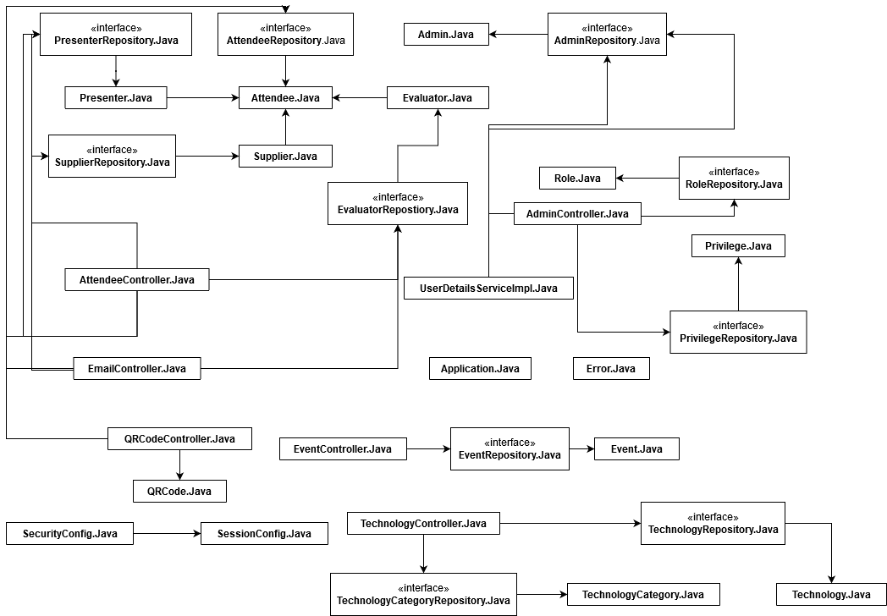

Please note: We are using a backend SpringJava library. Pointers are set according to how we built our connections through the code. Spring has so many different connections that we cannot account for them in the Class Diagram.

## Sequence Diagrams

### Register a Technology

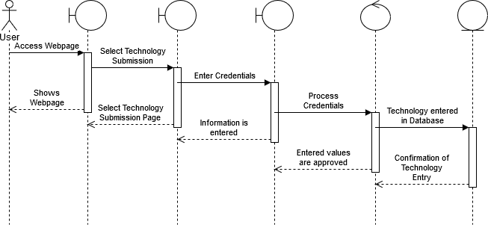

### Register as Evaluator

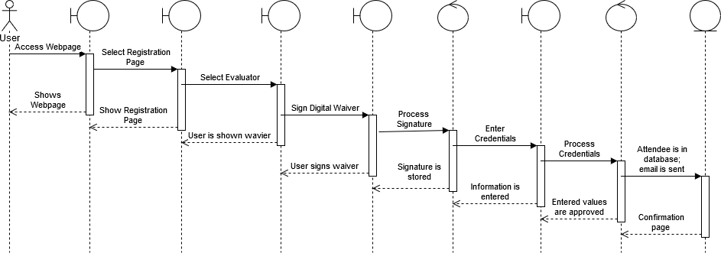

### Register as Supplier or Presenter

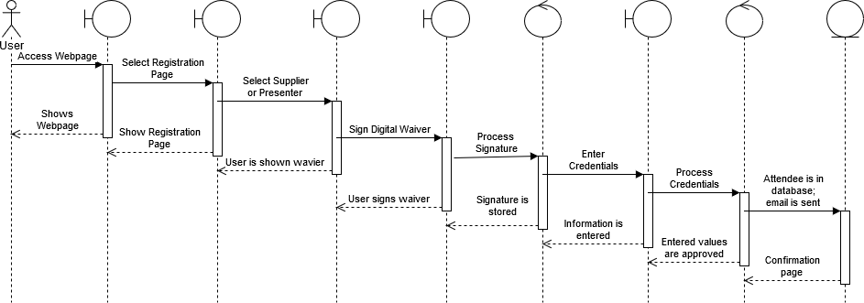

### Send Email

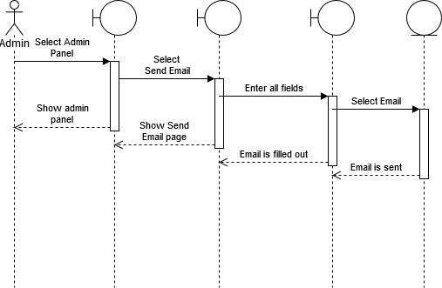

### Open or Close Event Registration

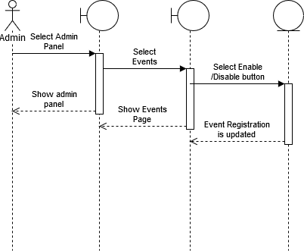

### Edit or Delete Events

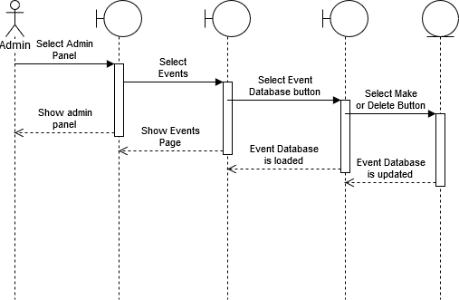

### Check In Attendee

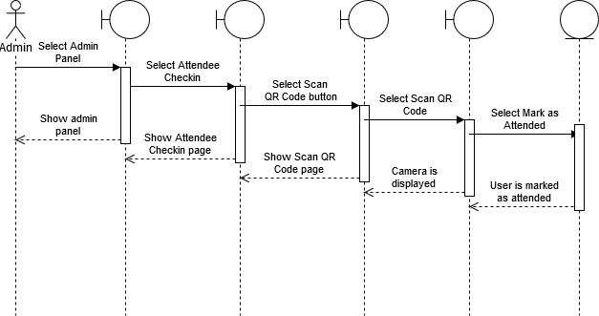

### Add or Remove Technology Category

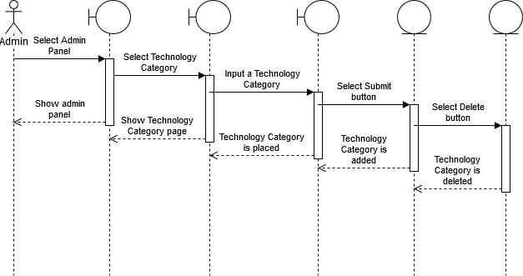

### Add, Edit, or Remove Technology

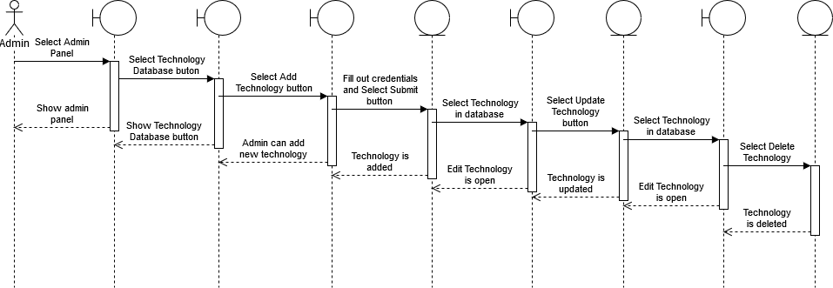

### Add, Edit, or Remove Attendee

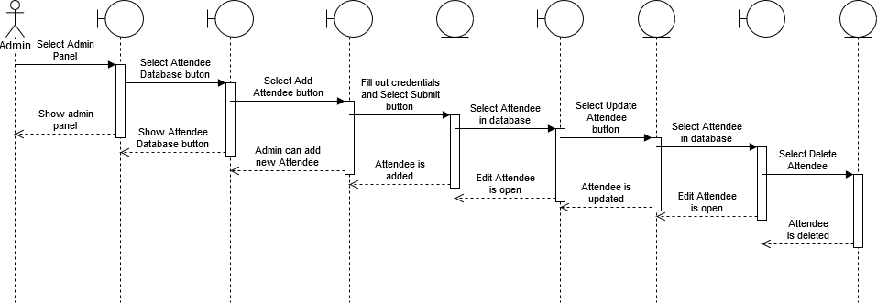

### Generate Badge Sheet

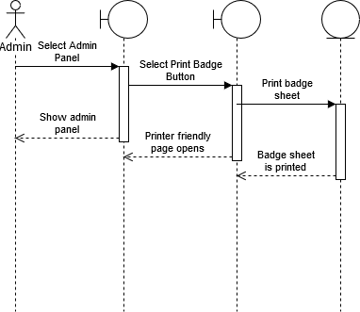

### 

### Pull Technology Database

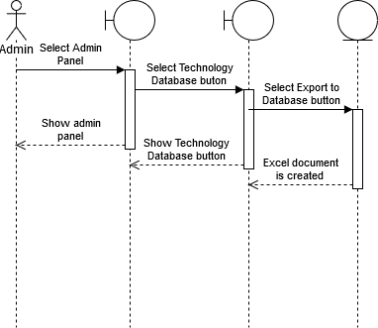

### Pull Attendee Database

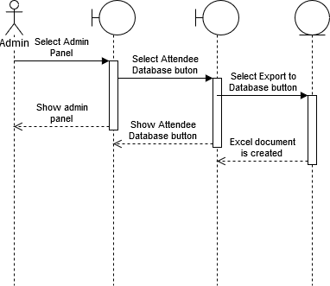

# Hardware Design

## Diagram

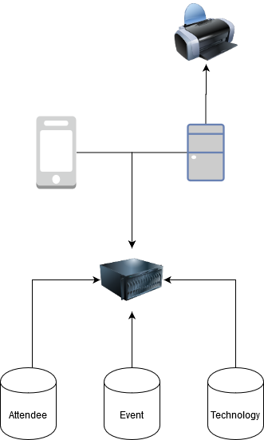

## Explanation

Our hardware for the project is as follows. We have three databases, those being Attendee, Event, and Technology. Each of these databases will be talking with the server that will house the actual website. Once the site is launched, both Mobile and PC can launch the site. We have a printer only connected to the PC since this is how we will allow our badges to be printed.

# Software Design

## Data Design

### Internal Software Data Structure

The data structure would be talked through the UI, to a validation system, and transfer it to the database. When an admin wishes to view the current listing of attendees or technologies that are submitted, a link would tell the database to display its contents in a UI fashion table.

### Global Data Structure

The ability to pass back and forth information in the database to the user interface would be denoted here. This is used for storing needed information into the database and make it as easy to allow the database to display the data in a user friendly manner on the site.

### Temporary Data Structure

N/A

### Database Description

There are two databases that are created within our website. The first one would house the technologies that a user can submit. The fields would be the concept title, description, technology category, concept type, shipping city, shipping country, source, ford contact and presenter, director, and supplier company. The other database is for attendees. This would contain an attendee’s email, first and last name, phone number, city, country, technology to be associated with, and dates of attendance.

## Architectural and Component-Level Design

### Program Structure

#### Architectural Diagram

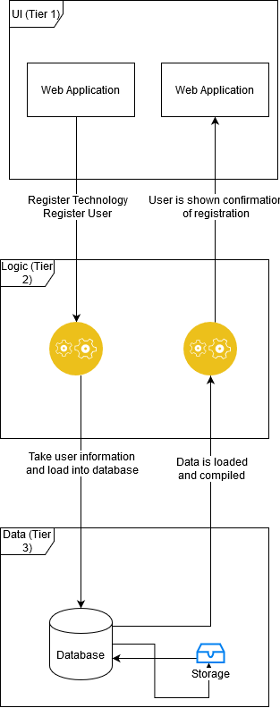

### Description for UI

#### Processing Narrative for UI

The user would be able to view the web application. From there, a user can choose to do features such as register a technology or registration for IDTE. They could also view information of the event, where it is located, and who to contact. If the user who is on the site is an admin, they would have special rights to their own panel.

#### UI Description

Users would enter the URL to access our site. This output would be the view of the webpage.

#### UI Open Webpage

* + - * 1. Input

Enter URL

* + - * 1. Output

Homepage of the website

* + - * 1. Algorithmic Model

Input the URL, talk with the logic to load the homepage

* + - * 1. Restrictions / Limitations

N/A

* + - * 1. Local Data Structures

N/A

* + - * 1. Performance Issues

N/A

#### UI Add User Registration

* + - * 1. Input

Into text fields: Email, Name, Phone Number, Technology Number, Ford Contact

* + - * 1. Output

User would click the submit button and receive a confirmation email

* + - * 1. Algorithmic Model

Text boxes are displayed to the user, and the user would enter a string value into each field. Once all fields are filled out, click the submit button

* + - * 1. Restrictions / Limitations

N/A

* + - * 1. Local Data Structures

N/A

* + - * 1. Performance Issues

N/A

#### UI Add Technology Registration

* + - * 1. Input

Into text fields: Technology name, category, Name, email, phone number, Ford contact

* + - * 1. Output

User would click the submit button and receive a confirmation email

* + - * 1. Algorithmic Model

Text boxes are displayed to the user, and the user would enter a string value into each field. Once all fields are filled out, click the submit button

* + - * 1. Restrictions / Limitations

N/A

* + - * 1. Local Data Structures

N/A

* + - * 1. Performance Issues

N/A

#### UI Edit User Registration

* + - * 1. Input

An admin would select the Attendee Database option and select an attendee to edit

* + - * 1. Output

Admin would click the update registration button on the Edit Attendee view

* + - * 1. Algorithmic Model

Admin would login to the site. Then, they would select the Attendee database button. Afterwards, they would search the attendee that they want to find and select said attendee. They would edit the fields as requested and select the “Update Attendee” button.

* + - * 1. Restrictions / Limitations

Only admin accounts can edit an attendee registration. If a user wishes for credentials to be changed, they would have to contact Ford directly through the Contact Info tab on the site

* + - * 1. Local Data Structures

N/A

* + - * 1. Performance Issues

N/A

#### UI Edit Technology Registration

* + - * 1. Input

An admin would select the Technology Database option and select a technology to edit

* + - * 1. Output

Admin would click the update technology button on the Edit Technology view

* + - * 1. Algorithmic Model

Admin would login to the site. Then, they would select the Technology database button. Afterwards, they would search the technology that they want to find and select said Technology. They would edit the fields as requested and select the “Update Technology” button.

* + - * 1. Restrictions / Limitations

Only admin accounts can edit a Technology registration. If a user wishes for credentials to be changed, they would have to contact Ford directly through the Contact Info tab on the site

* + - * 1. Local Data Structures

N/A

* + - * 1. Performance Issues

N/A

#### UI Export Data to Excel

* + - * 1. Input

Admin would click a button on the Technology or Attendee database and select the Export to database button

* + - * 1. Output

Excel document would be created and can be viewable to the user

* + - * 1. Algorithmic Model

User is an admin. Select the admin page. Select the Attendee or Technology database. Select Export to Excel button

* + - * 1. Restrictions / Limitations

User would have to be an admin

* + - * 1. Local Data Structures

N/A

* + - * 1. Performance Issues

N/A

#### UI Change View of Webpage

* + - * 1. Input

User selects an option to change the view of the website to a new page

* + - * 1. Output

User is shown the new page on the website

* + - * 1. Algorithmic Model

Select button on navigation view. User would be shown the selected page

* + - * 1. Restrictions / Limitations

N/A

* + - * 1. Local Data Structures

N/A

* + - * 1. Performance Issues

N/A

#### UI Digital Waiver

* + - * 1. Input

User would select Register Attendee

* + - * 1. Output

User is shown a digital waiver that needs to be signed

* + - * 1. Algorithmic Model

Select Register Attendee. Select the checkbox. Select Submit button.

* + - * 1. Restrictions / Limitations

N/A

* + - * 1. Local Data Structures

N/A

* + - * 1. Performance Issues

N/A

### Description for Logic

#### Processing Narrative for Logic

The logic layer would run the commands that are selected by the user. These options could be viewing a certain page on the webpage, viewing the values in the database, exporting an excel document of the databases, etc. It all depends on user restrictions that are defined by an admin.

#### Logic Description

Commands would be run depending on the selections chosen by the user. When a button is selected, the user would be taken to that page view or the frontend would talk to the backend.

#### Logic for changing page

* + - * 1. Input

Click on a button on the UI to load a new section of the web app

* + - * 1. Output

Logic behind the scenes is run and would talk to the database or load a new page. Depending on the user input

* + - * 1. Algorithmic Model

Click on button, wait for talk to the server, load the changes

* + - * 1. Restrictions / Limitations

Need to be connected to website

* + - * 1. Local Data Structures

N/A

* + - * 1. Performance Issues

N/A

* + - * 1. Design Constraints

Size of the screen can affect the button a user can click. If it is small enough, then they may load a different page then what they would want to.

#### Logic for Registering User

* + - * 1. Input

User has data filled out and clicked on the submit button

* + - * 1. Output

Data is added to the database

* + - * 1. Algorithmic Model

The logic would check if all necessary fields are filled out. If all fields are filled out, add it to the database. If not, notify user with an error and allow them to fill out missing fields

* + - * 1. Restriction / Limitations

N/A

* + - * 1. Local Data Structures

N/A

* + - * 1. Performance Issues

N/A

* + - * 1. Design Constraints

N/A

#### Logic for Registering Technology

* + - * 1. Input

User has data filled out and clicked on the submit button

* + - * 1. Output

Data is added to the database

* + - * 1. Algorithmic Model

The logic would check if all necessary fields are filled out. If all fields are filled out, add it to the database. If not, notify user with an error and allow them to fill out missing fields

* + - * 1. Restriction / Limitations

N/A

* + - * 1. Local Data Structures

N/A

* + - * 1. Performance Issues

N/A

* + - * 1. Design Constraints

N/A

#### Logic for Changing User information

* + - * 1. Input

User would have their registration loaded and changed

* + - * 1. Output

Data is updated to the database

* + - * 1. Algorithmic Model

The logic would check if any changes are made. If there are, then it will update the values in the database. If no changes are made, then nothing in the database would change.

* + - * 1. Restriction / Limitations

N/A

* + - * 1. Local Data Structures

N/A

* + - * 1. Performance Issues

N/A

* + - * 1. Design Constraints

N/A

#### Logic for Changing Technology information

* + - * 1. Input

User would have their technology information loaded and changed

* + - * 1. Output

Data is updated to the database

* + - * 1. Algorithmic Model

The logic would check if any changes are made. If there are, then it will update the values in the database. If no changes are made, then nothing in the database would change.

* + - * 1. Restriction / Limitations

N/A

* + - * 1. Local Data Structures

N/A

* + - * 1. Performance Issues

N/A

* + - * 1. Design Constraints

N/A

#### Logic for Exporting data to Excel

* + - * 1. Input

An admin would make the selection to export the database to an excel document

* + - * 1. Output

The logic would generate an excel file from the data pulled in the database

* + - * 1. Algorithmic Model

The logic would look at the database. Then organize the data according to columns. Place each value into the correct cells. Export to an excel file.

* + - * 1. Restriction / Limitations

Need to be an admin to run this feature

* + - * 1. Local Data Structures

N/A

* + - * 1. Performance Issues

N/A

* + - * 1. Design Constraints

N/A

### Description for Data

#### Processing narrative for Data

The Data layer would house the data that is populated within the website. Data included would be Users attending the event, technologies that would be on display, and what days to expect the technologies.

#### Data Interface Description

The database is used to house all information for the website. Any inputs loaded into the database would be controlled through the UI layer of the site. From there, logic would be conducted to know what to add into the database or what to change.

#### Adding User to the database

* + - * 1. Input

User has clicked the submit button and logic was ran

* + - * 1. Output

Data is loaded into the database into the correct locations

* + - * 1. Algorithmic Model

Database would look at the reference in the table. Place the values according to the pointers in the backend

* + - * 1. Restrictions / Limitations

N/A

* + - * 1. Performance Issues

N/A

* + - * 1. Design Constraints

N/A

#### Adding Technology to the database

* + - * 1. Input

User has clicked the submit button and logic was ran

* + - * 1. Output

Data is loaded into the database into the correct locations

* + - * 1. Algorithmic Model

Database would look at the reference in the table. Place the values according to the pointers in the backend

* + - * 1. Restrictions / Limitations

N/A

* + - * 1. Performance Issues

N/A

* + - * 1. Design Constraints

N/A

#### Updating User to the database

* + - * 1. Input

Admin has clicked the Update Attendee button and logic was ran

* + - * 1. Output

Data is loaded into the database into the correct locations

* + - * 1. Algorithmic Model

Database would look at the reference in the table. Place the values according to the pointers in the backend

* + - * 1. Restrictions / Limitations

N/A

* + - * 1. Performance Issues

N/A

* + - * 1. Design Constraints

N/A

#### Updating Technology to the database

* + - * 1. Input

Admin has clicked the Update Technology button and logic was ran

* + - * 1. Output

Data is loaded into the database into the correct locations

* + - * 1. Algorithmic Model

Database would look at the reference in the table. Place the values according to the pointers in the backend

* + - * 1. Restrictions / Limitations

N/A

* + - * 1. Performance Issues

N/A

* + - * 1. Design Constraints

N/A

### Software Interface Description

#### External Machine Interfaces

N/A

#### External System Interfaces

We are talking to an internal Ford server. This will ensure security to the users and technologies that are submitted for IDTE.

#### Human Interface

The user would be able to view a web page that is accessible through a web browser.

## User Interface Design

### Description of the User Interface

The user interface is a web page browser. There is a navigation bar for the user to have access to. There are options to submit a technology or register as a user. For registering as a user, the user must sign a digital waiver. There is an admin only page view that would be detailed more in screen shots. A drop down is included for information regarding the event. The admin page is hidden unless an admin account is signed into the site. This can be accessed by selecting the “Admin” button on the footer of our site.

#### Screen Images

Screenshots of our site can be found in Appendix B of the document.

#### Objects and Actions

* Clicking the sign button on digital waiver takes user to the attendee registration page
* Selecting the Technology button takes user to submit a technology, no waiver signature needed
* Selecting the home button takes the user to the homepage
* Selecting the register button would allow the user to choose to register as a supplier, presenter, or evaluator
* Selecting technology submission option would allow the user to register a technology
* Hovering over the information tab would take the user to view options Event Info, Event Map, Display Layout, Contact IDTE
* Selecting one of the above options takes the user to the respective view on the webpage
* Selecting the admin page would take user to the admin page view
* Selecting Technology Database and selecting a technology would allow an admin to make changes to a technology
* Selecting Attendee Database and clicking on an attendee would allow an admin to make changes to a user
* Admins can open or close registrations for technology and attendees
* Selecting the attendee checkin button would open the Scan QR code page where a QR code can be scanned via webcam
* Selecting the attendee checkin button would open the Scan QR code page where an admin can look up an attendee and register them without use of QR code scan
* Selecting Edit Event Dates would change the dates of IDTE, this can ensure the site can be used for continuous years
* Selecting Export to Database would export Attendee and or Technology Database to an excel document
* Selecting Print Badge button would generate a printer friendly badge sheet
* Selecting Admin Account button would allow an admin to add or remove new admins
* Selecting Send Email button allows an admin to send an email to individuals or specific groups

### Interface Design Rules

* Keep it simple
* Users are in control
* Make user interfaces consistent

### Components Available

* Buttons
* Navigator
* Drop downs
* Text fields
* Labels

### UIDS Description

* Node.Js
* HTML
* CSS
* JavaScript
* Java
* MySQL

## Restrictions, Limitations, and Constraints

* The proposed earlier date for the project may prove difficult to meet each respective requirement for the software. Additionally, the expedited schedule may sacrifice some overall software stability for an earlier delivery.
* Due to the single threaded nature of Node, CPU heavy processes may slow down the software as a whole while new functions are queued. This also means that if a part of the software causes Node to crash, all requests on the thread will crash as well.
* Each team member will be using his own personal computer when working on the project, and as such each machine may perform differently when trying to use the software

# Implementation Details

# Testing

## Testing Strategy

### Unit Testing

When we conduct our unit testing, each use case that we have implemented would be tested. The testing will be conducted through white box where each use case prepared would be tested individually. The use cases would be tested by passing through custom made data and see if any errors occur. Along with features mentioned above, entry and exit conditions would also be met. Any Unit Testing would be conducted by the programmer who created the use case. If needed, we would have a second programmer be a tester as well to see if anything needs to be updated or changed prior to a final release.

### Integration Testing

This testing can only be conducted once we have access to Ford Servers. If that is not possible, then this portion of testing cannot be conducted. This has already been mentioned in our major constraints in section 1.3. If the above is met, we can begin testing on our client’s servers and measure our results. Various testing scenarios that we would do can be denoted by the following. Conduct a full workflow of registrations as if we were a normal user. Verify admin rights work as expected on a live server. Once all of the conditions are met, we will feel confident with launching our software to their servers.

### Validation Testing

This testing that we conduct would be run with the full understanding of being a normal user using our software. This is important to keep in mind since as the programmers and testers, we know HOW this product would be built and run as expected. This approach can be used with black box testing where we test all components of the product at once. Any issues that could be found here can be denoted accordingly in various test cases. The goal of our validation testing is to take a fully functional, bug free product to the customer so they can walk away happy and know that this is something that is usable for them.

### High-order Testing

The below test cases would be used to cover for different conditions that we would not be putting a focus on during other testing scenarios. These testing scenarios would be run when we reach big milestones in our project.

#### Recovery Testing

This testing would be conducted to confirm that if a database were to lose connection to our site, the information that is stored would not be lost. The biggest idea here is to cover for loss of technologies or users.

#### Security Testing

We want to use this testing to be sure that the site is secure. With having people’s personal information on our site, we want to be sure that unless you are an admin, only your own person can view your own personal information.

#### Stress Testing

We want to use this testing to see how our site would run when there is an overload of processes being run on a computer. This can help us see if any changes are needed to be made to our site to prevent any crashes from happening.

#### Performance Testing

We want to use this kind of testing to make sure that our product is running to the best of the ability. Since we have different kinds of users using our site, we have to make sure that speed is consistent regardless of bandwidth from a router.

#### Alpha/Beta Testing

We want to run testing levels when we send updates to the client. Since this product is in use with a team of people, we want to be sure that all parts of the project works. The client would want to have Technology Concepts completed by a certain date, so testing will be put on a bigger emphasis in said phases.

#### Pass / Fail Criterion for all Validation Tests

We are defining clear specifications for when a test case passes or fails. A test case is considered passing when all criteria are met. If there is any criteria that does not match, then the test case would be considered as failed and be submitted as a defect in the backlog.

## Identification of Critical Components

* User Interface
* Valid Data
* Invalid Data
* Data Exports
* Database Management

## Test Cases

Our test cases can be found using the following link:

[Test cases](https://docs.google.com/spreadsheets/d/1XPkBR5359MXlg5lZw-4pubM4i45MODKN/edit?dls=true#gid=219507181)

# SQA

## Introduction

### Scope and intent of SQA activities

The team's objective is to ensure the product does deviate from the scope of our project as defined with the client. If an issue arises, it will be brought up immediately and would be presented to the client as necessary. The team will also inquire about any new ideas or features that may be seen as useful for the client. At which point, the team lead would contact the client and discuss the changes.

### SQA Organizational Role

The role is to review the product at specific times during implementation. These would be defined once implementation of the project has begun and the SQA would need to be in contact with the developer to know what to validate. If there are any defects that arise action would be taken immediately.

## SQA Tasks

### Task Overview

#### Description of SQA Task

##### Task 1

The team member working on the database design would reference the SRS to make sure they’re design matches what is defined as discussed with the customer. With this idea, the client’s standards and expectations will be reached and work properly.

##### Task 2

The team member working on the User-Interface design would reference the SRS to make sure they’re design matches what is defined as discussed with the customer. With this idea, the client’s standards and expectations will be reached and work properly.

##### Task 3

Each team member will do some hands-on work with the User-Interface. This is to ensure that it follows the three golden rules of User Interface.Design. User is always in control, Interfaces are consistent, and reduce the user's memory load.

##### Task 4

The team lead would be appointed as the SQA leader. This is because the team lead would keep in touch with the client for updates on the current project. Any defects brought up through testing would be tackled accordingly by severity levels. The team would all sit down and discuss what defects would need to be fixed first before continuing with new functionality.

##### Task 5

There would be a main source of testing documents conducted throughout the project. Anyone on the team has access to these test cases and would be run prior to any release to the customer. This is to ensure that any defects that may exist would be brought up to the customer prior to the release and actions would be taken with respect to the types of defects that are found.

#### Work Products and Documentation

##### Task 1

This would make sure the database design matches what was discussed with the client. Any concerns that may come up during testing would be documented accordingly with the method the team would use while conducting the project.

##### Task 2

This would make sure the User-Interface design matches what was discussed with the client. Any concerns that may come up during testing would be documented accordingly with the method the team would use while conducting the project.

##### Task 3

Each team member is responsible to take a look at the User-Interface during all phases of the project. Any issues that may come up or ideas for changes would be documented accordingly and be discussed in a future meeting with the client if deemed important. No changes to the User-Interface design would be changed without approval from the client.

##### Task 4

All suggestions or concerns during any discussion would be recorded. Each item discussed will be tagged with the date it was reviewed and severity level. Any ideas for implementations or enhancements would also be mentioned during these meetings.

##### Task 5

The location where these test cases are held will be determined by the team. At the request of the client, we can provide these test cases so the client and other users can conduct the same testing ideas that the team used.

### Standards, Practices, and Conventions

Developers on their given tasks are responsible for turning in the functionality for QA testing by the set date as defined in the PMP. This approach would ensure that the project will be released on time. Any issues that may come up during QA testing should be reported immediately and development should take on the role. Prior to a developer releasing their functionality or bug fix, Unit Testing must be conducted. This is to make sure the code is logically correct and cannot be broken by a user.

### SQA Resources

Since this is a four person team, there will not be one SQA Lead that watches over other testers. The goal is to have everyone test parts of the code that they did not touch as to ensure assumptions do not exist. Each team member is responsible to write any defects found, regardless if it is under development or testing. The location where the test cases are listed should be updated frequently throughout the process of the project.

## Reviews and Audits

### Generic Review Guidelines

#### Conducting a Review

The software will be reviewed on a weekly basis to account for errors that may have arisen in the development process and to attempt to catch them before development gets too deep. The reviews will consist of each member running through the software testing different aspects that will be assigned before the tests begin, with each defect they find being scored somewhere between 1(Catastrophic) to 4(UI flaw). Afterwards the team will congregate and discuss the defects each person has presented, and if necessary attempt to recreate them.

#### Roles and Responsibilities

Each team member will be responsible for thoroughly combing through his module to find any defects that may be present. After which the SQA leader will lead a discussion about the different defects each member has found, and record them afterwards. During this time the SQA will prompt the team members for the route to correct the aforementioned errors.

#### Review Work Products

Each team member will have an official record of the defects they may have come across during their technical reviews. The SQA will have a “master” list so to speak, having each defect catalogued. The master list will also record who was assigned to handle the defect, if the defect was resolved since the prior technical review, and if so the date that it was resolved.

### Formal Technical Review

#### System Specification Review

##### Description and focus of the review

The system specific review aims to find any major defects with the overall design of the system as previously outlined in the System Specification document.

##### Timing of the review

The review will be held once the overall system design document has finished, which is planned to take place a few weeks before development begins.

##### Work products produced

The SQA leader will create a log of the reported defects as found when conducting the review, and if any defects are found, they will meet with the team and get suggestions for how the defect can be resolved.

##### Review checklist

-Can the design be better?

-Are we using the proper frameworks?

-Is the timeframe realistic for the design of the document?

-Are there any possible additions that would enhance the software?

#### Software Project Plan Review

##### Description and focus of the review

The Software Project Plan Review will be conducted to determine if the planned schedule of the software and financial costs are practical. If they are not, the team will discuss possible alterations to the schedule and financial costs, and adjust the Software Project Plan as necessary.

##### Timing of the review

It is preferred to have the Software Project Plan Review done after the Software Project Plan has been completed and when development for the software begins; this is to attempt to stay on track according to the planned schedule for the software and within the bounds of the allotted financial assets.

##### Work products produced

The SQA leader will have a list of any over/under estimates regarding the software scheduling and the financial bounds that the project is limited to. If there are any notable concerns from either of the two, the team will discuss possible ways to adjust the values to something that works better for the Software Project Plan.

##### Review checklist

-Is there enough time for the completion of the project within the current schedule?

-Have the schedule and financial assets been set properly?

-Is the development of one or more components allotted too little or too much time?

#### RMMM Review

##### Description and focus of the review

The focus of the RMMM review is to determine if the current risk management for the software in development is feasible.

##### Timing of the review

This review will take place after the RMMM document is complete, which should be within the first few weeks of development. The RMMM review is necessary to provide a guideline on how problems will be handled if proposed risks happen early in development.

##### Work products produced

SQA leader creates a summary report of the RMMM review. Included in this report is: any possible risks not covered and risks that have been accounted for but are not correctly managed. Upon a proposal of an additional risk, a discussion will be held and the team will conclude on how to manage said risk. Also, within this discussion the team will determine how to manage other risks that are being managed inappropriately.

##### Review checklist

Have all risks been thoroughly covered in the document? If not, what is missing?

Of the risks covered in the document, are there any that did not seem to be effectively covered? If yes, which one(s)?

Of the risks covered in the document, are there any that did not seem to be appropriately managed? If yes, which one(s)?

#### Requirements reviews (models, specification)

##### Description and focus of the review

This review aims to analyze the current software design proposal. Additionally this review will remove or discuss changes to any design flaws that are obvious. Once a defect is found, then the SQA team will cooperate with the Software Engineer team to decide on how to compensate for the design flaw.

##### Timing of the review

After the review specification document is completed this review will be held. Which takes place within the first few weeks of development. The reason for the timing is to ensure that the design of the software is sound and will not cause problems in the future. Each software engineer will conduct this review to ensure that the software aligns with the design. If any discrepancies are found then they will be brought up to the SQA leader and a discussion will be held to solve the problem.

##### Work products produced

The SQA leader will create a report that includes any defects or enhancements that have been brought to attention. Once defects have been identified, then the SQA team will discuss possible solutions. Documentation of all possible solutions will be created and reviewed again to determine if the solution will impact the design. If design changes are made the Requirements specification document will be amended.

##### Review checklist

Is the proposed design the best possible solution?

Are there any obvious design flaws that have not been accounted for? If yes, what?

Are there any necessary enhancements for the software?

Is the proposed Requirements Specification within the time frame?

#### Data design review

##### Description and focus of the review

The focus of the Data Design review will be to look over the major data objects found within the software. Specifically, whether or not the intended operations of the software is within the possibilities of the chosen language for the project. The languages that will have a part in the software will be HTML & CSS, Javascript, Java, and SQL. Additionally, we will be looking at if each object was designed and implemented efficiently.

##### Timing of the review

The time of the review will take place within a few weeks from when development starts. This is to ensure each data member is set before going forward with development, and to ensure. Each team member will conduct reviews on the data objects that he had a part of working with, and will report any defects to the SQA leader to be addressed later.

##### Work products produced

The SQA will have a list of reported defects from the Data Design Review, and will discuss with the team the severity of each of them. The leader will then discuss possible solutions to the defects, and address if the proposed solutions had an impact on the defects.

##### Review checklist

-Is the data design the most practical one?

-Are any data objects structured in an un-intuitive manner that further complicates the software?

-Is the communication between data objects properly designed or is the communication too elaborate?

#### Architectural design review

##### Description and focus of the review

The purpose of the Architectural design review is to obtain a basis for analysis of the current software architectural design proposal. Specifically this review will focus on the assessment of the current design to make sure that data flow and control are being handled in the correct manner. If a design flaw is found then the Software engineers and the SQA team will attempt to provide a suggestion on how to compensate for the flaw.

##### Timing of the review

After both the Requirements and system specification documents are completed the Architectural design review document will be conducted.

##### Work products produced

A summary report will be created that includes any defects that have been discovered. After these defects are discovered the team will discuss possible solutions. All potential solutions will be documented in the report for later review. All changes will be amended to the Requirements and System specification documents.

##### Review checklist

Is the proposed architectural design the best possible solution?

Are there any obvious architectural design flaws that have not been accounted for (i.e. slow data flow or control)? If yes, what?

Are there any obvious changes you see would further enhance the software’s performance?

Is the proposed architectural design complete? If not, what seems to be missing?

Does the proposed architectural design seem possible within languages of choice? If not, why?

#### Interface (GUI) design review

##### Description and focus of the review

The GUI Design review will focus on whether or not the GUI fits the purpose of the software, looks pleasing, and is easy to use. If the client notes any issues they may have with the GUI, solutions will be discussed to adjust it accordingly.

##### Timing of the review

The GUI design review will be held once the Software Specification document and Requirements document are completed. The GUI will be relatively easy to design before the backend of the software is built, so it is planned to have the GUI design review done during the beginning of development.

##### Work products produced

The SQA leader will have a report of the review, which will list any changes that need to take place for the GUI, and what team member has been assigned to handle it. Naturally the Software Specification document and Requirements document will need to be changed if any new designs are going to be implemented for the GUI.

##### Review checklist

-Is the GUI simple enough to understand?

-Can the GUI be used easily?

-Does the GUI behave as expected?

-Is the GUI visually appealing?

#### Component GUI for Technology Concept database review

##### Description and focus of the review

This review aims to determine whether the Technology Concept database is structured in line with the design. If any defects or enhancements are possible then they will be handled via meeting/discussion.

##### Timing of the review

The Technology Concept database review should take place immediately after the Technology concept database is constructed and implemented. This will ensure that we can find defects as soon as possible due to having a limited time frame.

##### Work products produced

A report will be created by the SQA team lead that includes the status of the Technology concept database. Also this report will include all defects and enhancements brought up in meetings/discussion. All proposed changes will also exist within this document.

##### Review checklist

Does the GUI follow the UI golden rules?

Does the GUI function correctly?

Is the GUI how the Customer wanted it?

Is the GUI flexible to change?

#### Component GUI for Event Registration database review

##### Description and focus of the review

The focus of this review will be on the GUI for the Event Registration database. In particular, we will be determining if the GUI for the Event Registration is easy to understand and use, and is in accordance with how the client has required it.

##### Timing of the review

The review will take place within the first few weeks of when the software GUI is being built, since it will not take as long to create an early test layout of it before the software as a whole is completed. If parts of the GUI are found to be unsatisfactory from the client, the team will meet to address the changes necessary.

##### Work products produced

The SQA leader will have a report of the GUI for Event Registration database review, and included will be a list of proposed changes to be made to the GUI, along with the date of completion and the member working on it. The team will discuss the necessary actions to implement them accordingly.

##### Review checklist

-Is the GUI simple to understand?

-Is the GUI simple to use?

-Does the GUI behave as expected?

-Is the GUI visually pleasing?

#### Component Server Configuration review

##### Description and focus of the review

The focus of the Server Configuration review is to determine if the Server Connection is functioning as intended and is efficiently implemented. This review will also aim to make sure the server configuration aligns with the Ford company rules. If any defects are found then the SQA and Software Engineering teams will discuss a possible solution.

##### Timing of the review

This review should be conducted immediately after the first iteration of the Server Configuration is completed. Additionally this review will take place after each iteration. This is to ensure that the Server is implemented correctly and efficiently.

##### Work products produced

The SQA leader will construct a summary report of the Server configuration review. Included in this report is all defects or enhancements that have been discussed. Defects and enhancements that are documented will have a priority rank so the Software Developers can determine which defects/enhancements should be completed first.

##### Review checklist

Is the server easy to use?

Does every piece of functionality associated with the server connection work properly?

Does the server allow for enough flexibility?

Does the server make sense or not at all?

Is the server too tedious to use? If yes, why?

Are there any enhancements you would like to see in the server?

#### Code Reviews

##### Description and focus of the review

The Code Review will focus on whether the written code is efficient, modular, and written in a manner such that the rest of the team (or similarly other programmers) is able to comprehend its use and the logic that is involved. Code refactoring may be necessary.

##### Timing of the review

The best time to hold the Code Review will be near the end of the project's scheduled completion date, that way most if not all of the code will be written and almost finalized. However, it is preferred to have smaller code reviews during the project's lifespan to avoid a large cleanup during the project's final weeks.

##### Work products produced

The SQA leader will have a report made of the Code review, detailing any notable changes that have taken place or need to be implemented. Unless otherwise assigned, the member that originally wrote the code will be assigned to implement the changes.

##### Review checklist

-Is the code easy to read?

-Is the source code overly complicated?

-Can parts of the code be simplified?

-Is the code efficiently written?

#### Test specification review

##### Description and focus of the review

The purpose of the Test Specification review is to ensure proper software testing is enforced. If Test Specification is not thorough then the Test Specification document will be amended.

##### Timing of the review

This review will take place once the Test Specification document is completed. Doing so will help make sure that the proper testing procedures are being followed.

Once the product is completed this review will take place once more to ensure that the testing outlined within the Test Specification document has been followed.

##### Work products produced

The SQA leader will write a report entailing all changes that have or will be made to the Test Specification document.

##### Review checklist

Does the Test Specification seem to test each module thoroughly?

Are both black box and white box testing being used?

Are there any tests to any part of the software that you think are not being covered already?

Are there tests that seem to be overly redundant?

Is it specified that if changes are made to a software module how to deal with testing after the change takes place?

#### Change control reviews and audits

##### Description and focus of the review

The Change Control review will aim to determine we are following the correct procedure when a change is made to the design or implementation of software. Additionally the effectiveness of the Change Control document will be documented. If Change Control management problems are discovered then a discussion will be held to produce a solution.

##### Timing of the review

This review will take place upon completion of the Change Control document which will help avoid unnecessary changes and understand the impact a change will create on the whole system. The timing also helps to make sure a specific process takes place when submitting a change request.

##### Work products produced

A summary report will be created by the SQA leader. Included in this summary will be all changes that could possibly be added to the Change Control document. If any changes to the Change Control document seem sound then the Change Control document will be amended.

##### Review checklist

Does the Change Control document appear to filter out unnecessary changes in the product specification?

Are the appropriate actions being taken to ensure that any possible side effects are being evaluated?

Does the Change Control document contain a controlled method of change request?

Are change requests thoroughly evaluated?

Are change requests being thoroughly documented?

Is it specified who has the final decision with regards to the request?

### SQA Audits

Our team will conduct SQA audits monthly to ensure that the appropriate SQA activities are taking place and this will allow us to determine which specific activities are helping to deter product defects. Additionally the audits will keep the team in check and help us avoid activities that are less effective which allows us to become more effective.

To establish which activities to discard and which to continue using we will use our defect log. Also, the defect log will help us confirm that all the necessary enhancements and defect reports have been created and submitted along with any actions that have been made to handle said defect. The effectiveness of all defect handling methods will also be documented to determine which methods are most useful, and the most effective methods will be reused.

## Problem Reporting and Corrective Action

### Reporting mechanisms

Any defects or enhancements are brought up to the team lead. If defects occur between meetings with the team, it will be analyzed and assigned with the priority level. This can be done through email, discord, or in person.

### Responsibilities

There would not be one person in charge of assigning work to other team members during the project development. As a team, we will take our strong suits and put more emphasis on those parts. The only action that would be taken from the team lead is review of any defects found by other team members. This is to ensure that the standards are met and if not, they will re-open for further adjustments.

### Data collection and evaluation

The team lead will keep track of all defects or enhancements that are brought up during the duration of the project. The team lead would keep track of the problems and evaluate the priority level. Data would be collected during meetings and they would be kept track of through external documents outside of meetings.

### Statistical SQA

Any defect that is submitted will be analyzed by the team lead and kept track of using a tally based system. The cause of the defect will be kept track of. Once it is identified, the source will be discussed with the other team members to figure out what would be the best option for implementing the fix. Once the decision is made, the software would be analyzed and determined if the defect discussed would cause any new problems. Once enough time has passed, the group will meet again and discuss the best solution for the defect.

## Software Process Improvement Activities

### Goal and objectives of SPI

The goals of the SPI are to lower the amount of defects and determine underlying issues as to why these defects would occur. Once these issues are identified, actions would be taken to prevent these issues from occurring again. Changes that may be made would be adjusted to the scope and timing as well.

### SPI tasks and responsibilities

While testing is conducted, if a defect is found and documented, a count would be created. If there are continuous defects that surround a single functionality then proper actions would be taken. The first approach to the problem would be to look at the code itself. If the defects revolve around a single developer then the developer would be talked to with the team regarding their coding standards. If it is based around the entire team, then the team would sit together and discuss further actions. Once discussions are made and enough time has passed, the SQA lead would look at the count of defects again. If the problem persists, it would mean another sit down discussion and come up with different improvement ideas.

## Software Configuration Management Overview

Changes cannot be made in the software design without prior communication with the team lead and client. This must be done using a formal submission through email. The request is reviewed and determined how the changes would affect the scope of the project. If changes are planned to move forward, the PMP and SRS would be updated with the necessary changes. Any request made for a software configuration will be documented as a point of reference during the project.

## SQA Tools, Techniques, Methods

All practices used during testing would use the same guidelines and methods. Meetings conducted would expect everyone in attendance whether it be over the phone or in person. If a person cannot attend the meeting, notes written during the meeting would be emailed to the person missing. The team will look at defects and enhancements. From there, the team would determine severity levels and priorities. After a defect or enhancement is completed, it will be documented and stored for reference. A list of all defects written would be used to prevent duplicate defects from being written by various team members.

# Future Maintenance Suggestions

## General overview

Create a user friendly way to edit text screens such as information tabs and legal actions as shown in the digital waiver. Right now, there is no way to do this. Due to this being a new feature not in our original scope, this idea cannot be completed. It would also be helpful to allow users to edit their own credentials prior to an event instead of reaching out to administration. This would require more talking to the server and cannot have been created through running the server locally.

## Specific Pages

### Home

Have a view to show the actual events of the page. A suggestion would be to say something along the lines of “IDTE Event *start date* - *end date*

### Technology Submission

N/A

### Register

Have a way to remember when the digital waiver was signed. Since a user may choose a different Register type accidentally, skipping this one page would make the process easier.

### Information

#### Event Info/FAQ

As mentioned in the general overview, allow a way to easily edit fields such as this. An approach in this page specifically would be to have a textbox and button to update the text. This can only be done as an admin.

#### Event Map

The Event Map is just an image. Since this event may change every year, having a way to pull the address from this page would be easier since people could use GPS systems to know how to get to the location.

#### Display Layout

This is supposed to be a map of the different technologies on a given day. An approach to this would allow a submission of a PDF form where people can view the Layout of the campground. Since there are different technologies each day, this can be a way for it to be more organized.

#### Contact IDTE

This page is all text related. Since we would have the same information every year, nothing would need to be changed while on this page.

### Admin

#### Admin Account

N/A

#### Events

Have a way to specify that the main page shown is for editing the current event date setup while creating a new event would overwrite the existing event.

#### Attendee Checkin

Remove the second screen here. Since our only feature is the Scan QR Code Page, having this screen in between makes it feel redundant.

#### Attendees

N/A

#### Technology Categories

N/A

#### Technologies

N/A

#### Print Badges

N/A

#### Send Email

Have a way to load all emails in the database here. This could make it easier to send to a specific user if need be. Since we would have hundreds of emails, the slightest mistype may send an email to the wrong person.

#### Log out of Admin Account

N/A

# Delivery/Acceptance Statement

Our client has reached out to Professor Maxim directly signing off on our project via phone call. Will update this with a text based version of the acceptance letter once handed to us by the client.

# References & Bibliography

## References

### Project Management Plan

<http://www.rspa.com/docs/Projectplan.html>

### Software Requirements Specification

<http://www.rspa.com/docs/reqmspec.html>

### Software Quality Assurance

<http://www.rspa.com/docs/sqaplan.html>

### Design Document

<http://www.rspa.com/docs/Designspec.html>

### Test Plan

<http://www.rspa.com/docs/Testspec.html>

## Bibliography

|  |  |  |  |  |  |  |  |  |  |  |
| --- | --- | --- | --- | --- | --- | --- | --- | --- | --- | --- |
| U/R | R1 | R2 | R3 | R4 | R5 | R6 | R7 | R8 | R9 | R10 |
| US1 | X | X |  |  |  |  |  |  |  |  |
| US2 | X | X |  |  |  |  |  |  |  |  |
| US3 |  |  | X |  |  |  |  |  |  |  |
| US4 |  | X |  |  |  |  |  |  |  |  |
| US5 | X | X |  |  |  |  |  |  |  |  |
| US6 | X | X |  | X |  |  |  |  |  |  |
| US7 |  |  |  | X | X |  | X |  |  |  |
| US8 |  |  |  |  |  |  |  |  |  | X |
| US9 |  |  |  |  |  |  |  |  | X |  |
| US10 |  |  |  |  |  |  |  | X |  |  |
| US11 |  |  |  |  |  |  | X |  |  |  |
| US12 |  |  |  |  |  |  |  |  | X | X |
| US13 |  |  |  |  |  |  | X | X |  |  |
| US14 |  |  |  |  |  |  | X | X |  |  |
| US15 |  |  |  |  |  | X |  |  |  |  |
| US16 |  |  |  |  |  | X |  |  |  |  |
| US17 |  |  |  |  |  |  |  |  | X |  |
| US18 |  |  |  |  |  |  |  |  | X |  |

# Appendix A - User Manual

[User Manual](https://docs.google.com/document/d/1yMjpq-aVdDUzT1zSrHDorHqOWkHpwWVHOeMrjErjicY/edit#heading=h.su5cgc274v9p)

# Appendix B - Program Listing

## Sample Output

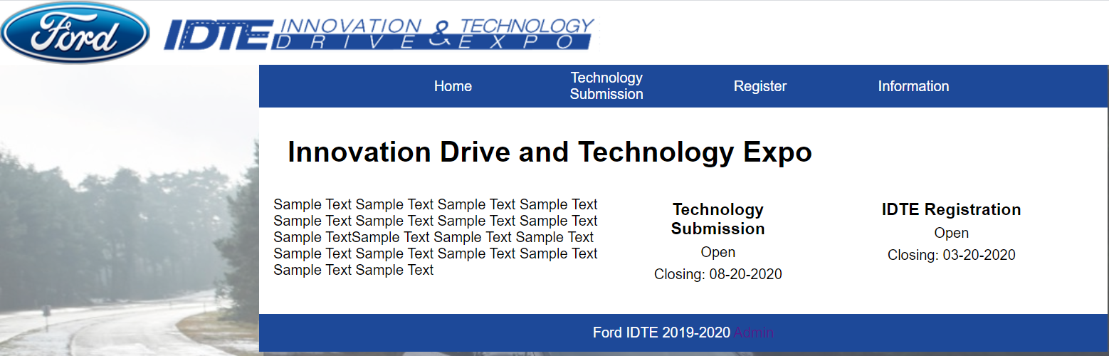

Homepage as a normal user (no login as admin)

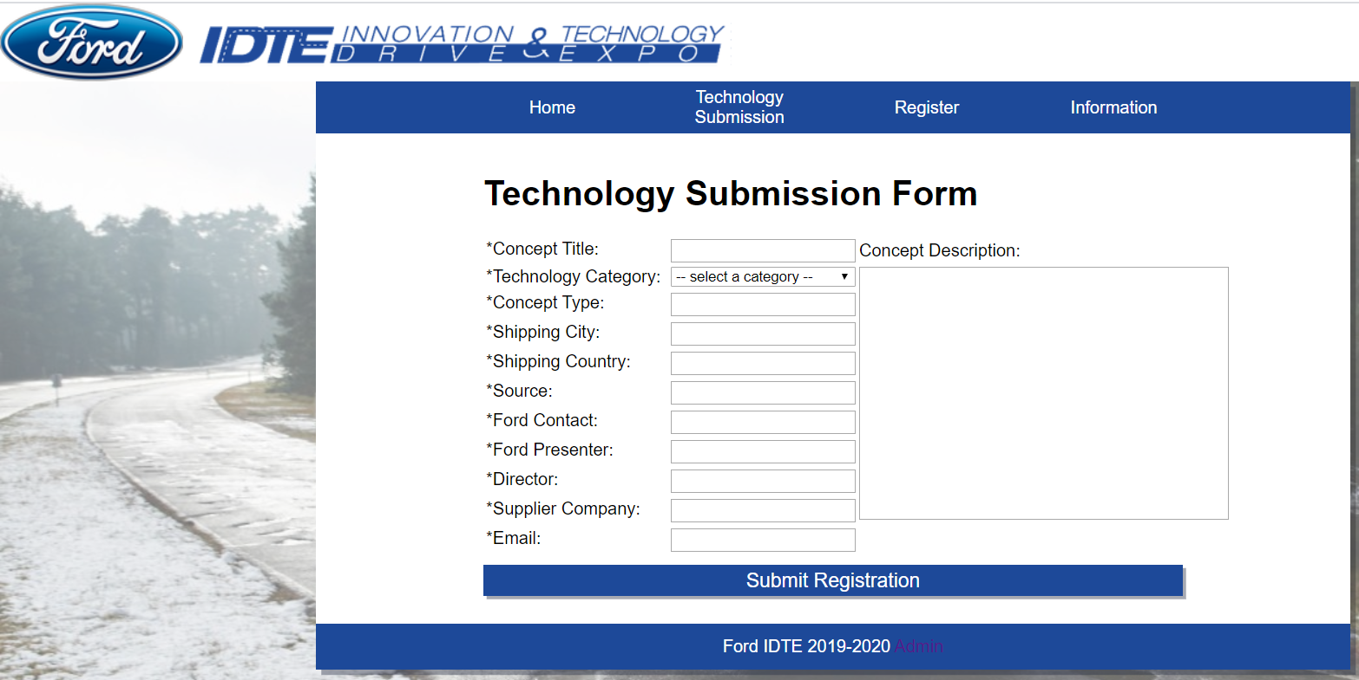

Technology Submission form

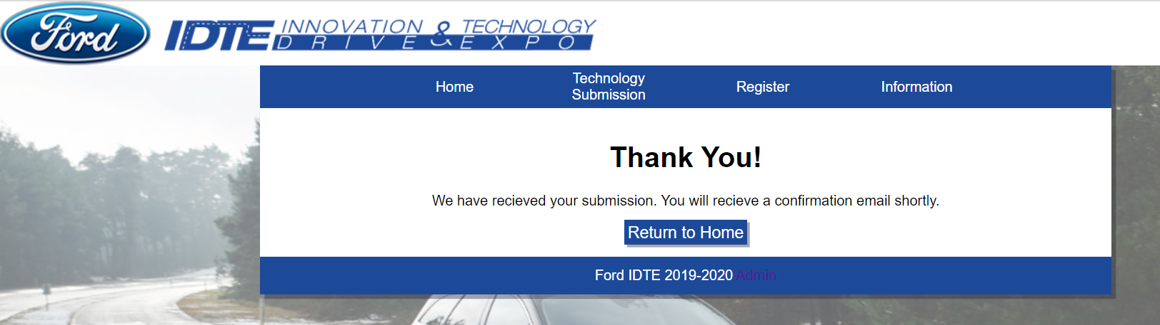

Confirmation page after registering a technology

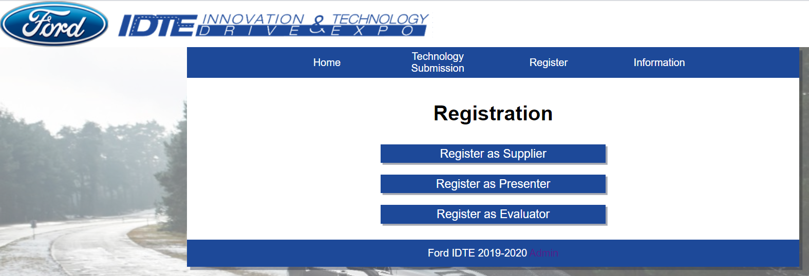

Selecting Registration type

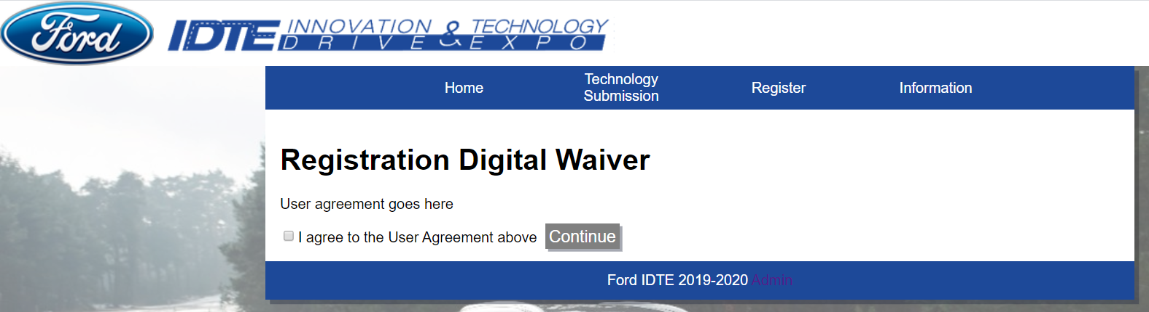

Registration Waiver

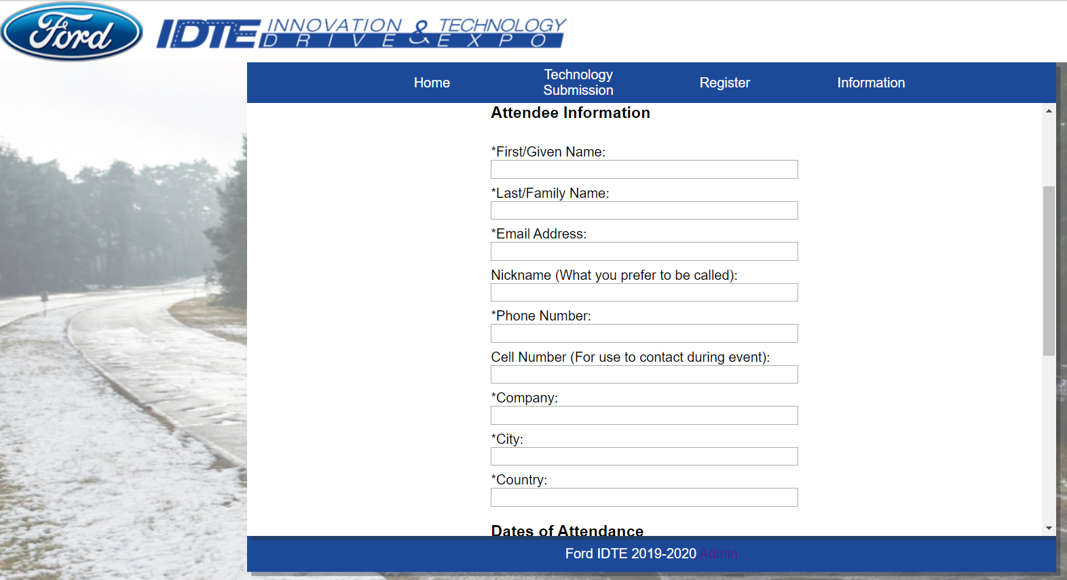

Attendee Information for Supplier / Presenter

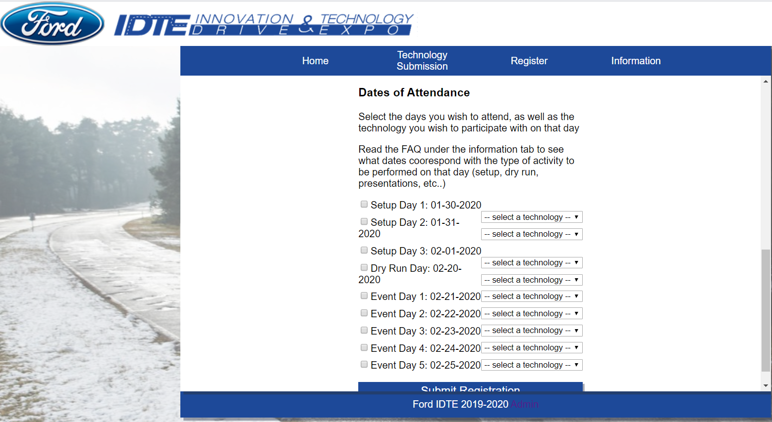

Dates of Attendance for Supplier / Presenter

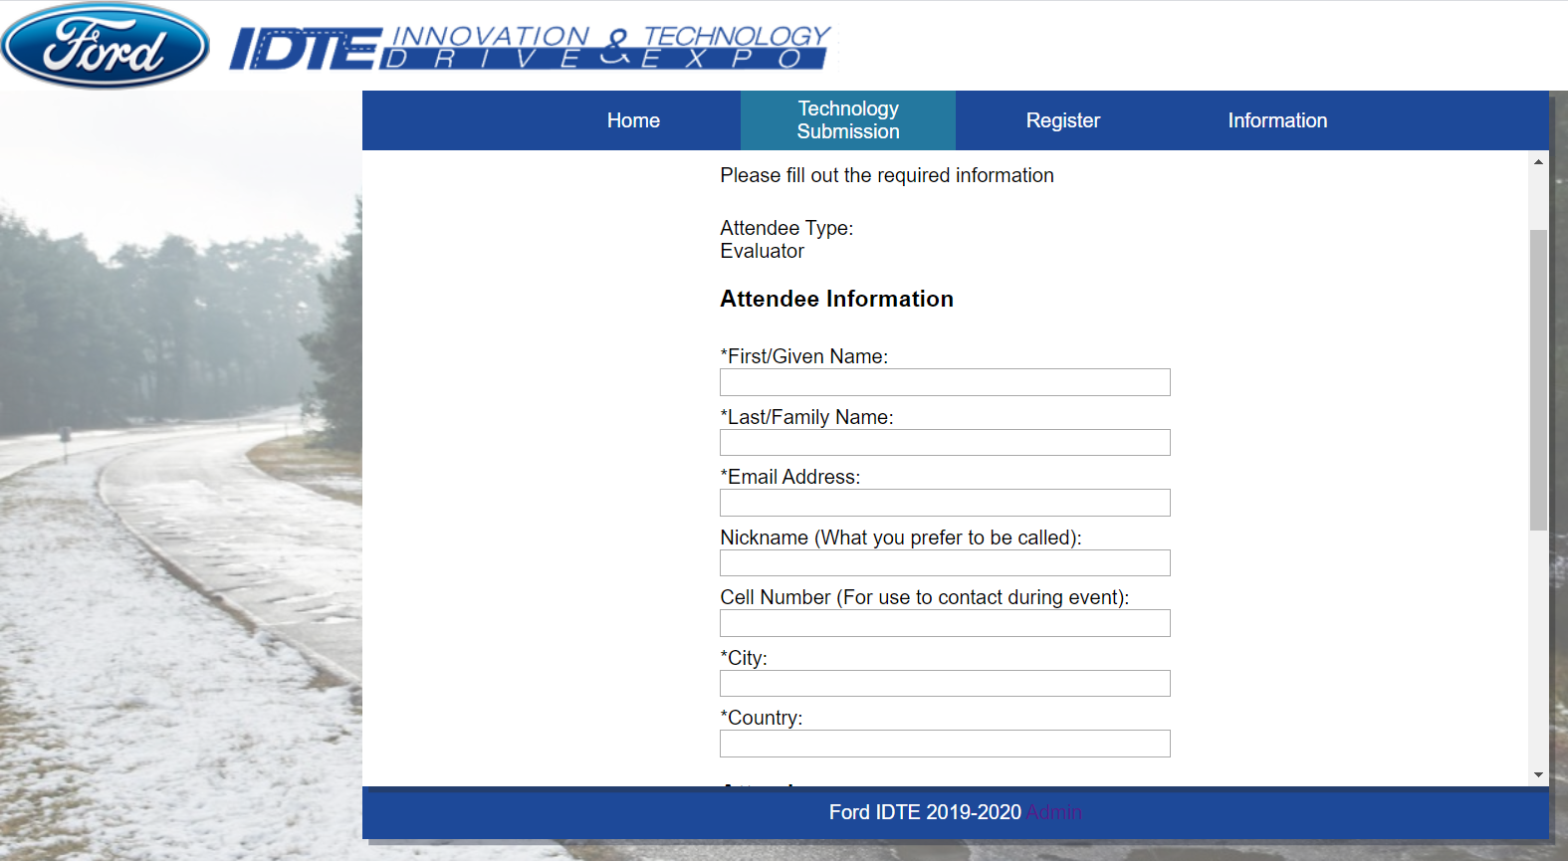

Attendee Registration for Evaluator

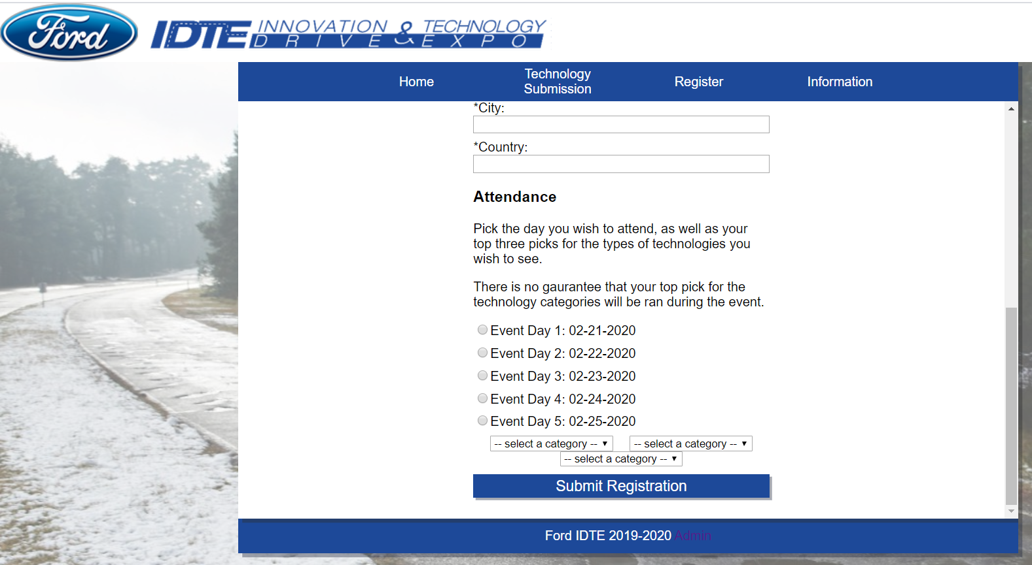

Dates of attendance for Evaluator

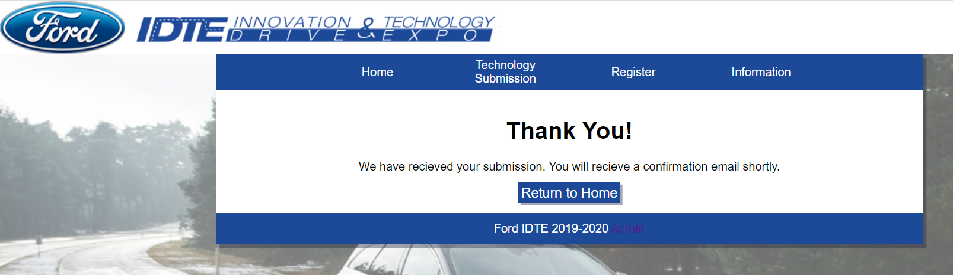

Confirmation page after submitting attendee registration

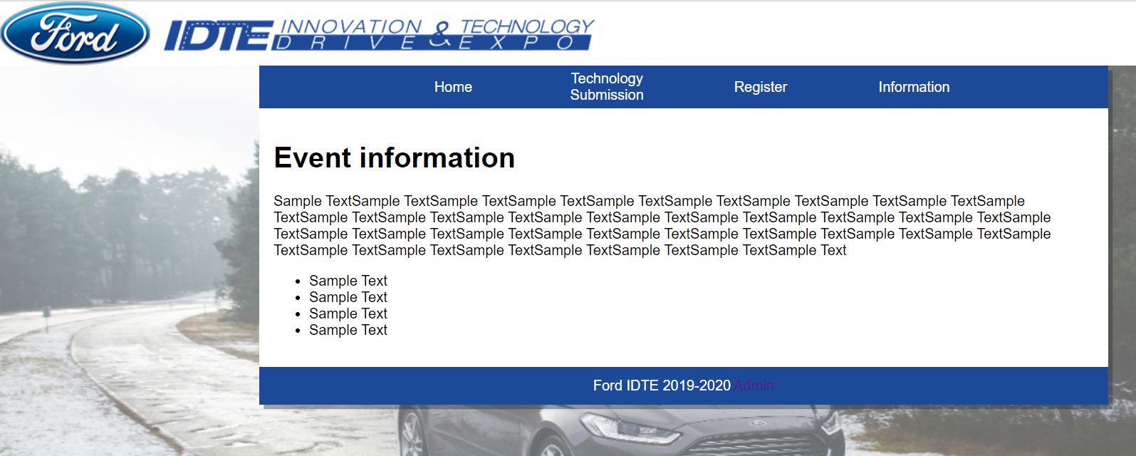

Event Information Page

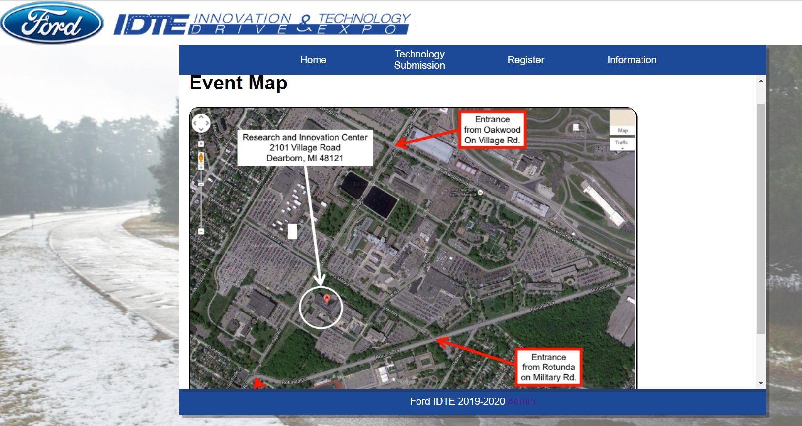

Event Map page

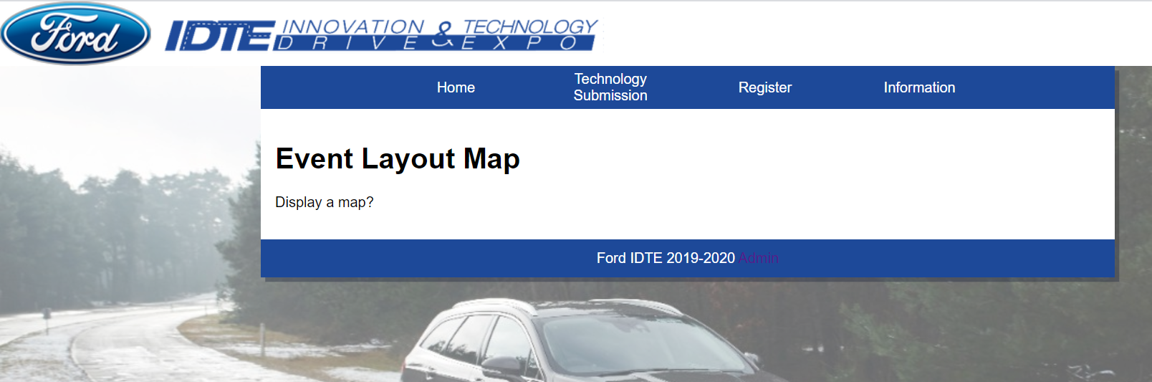

Event Layout Map

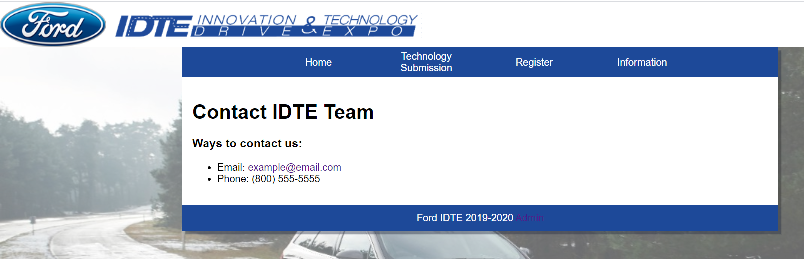

Contact Information page

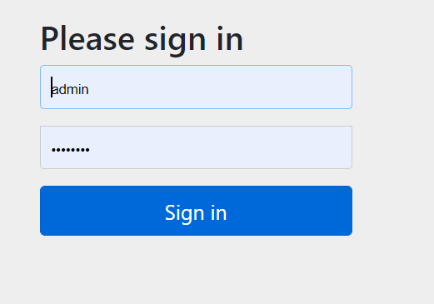

Admin login page (can be accessed by clicking the Admin button in the footer)

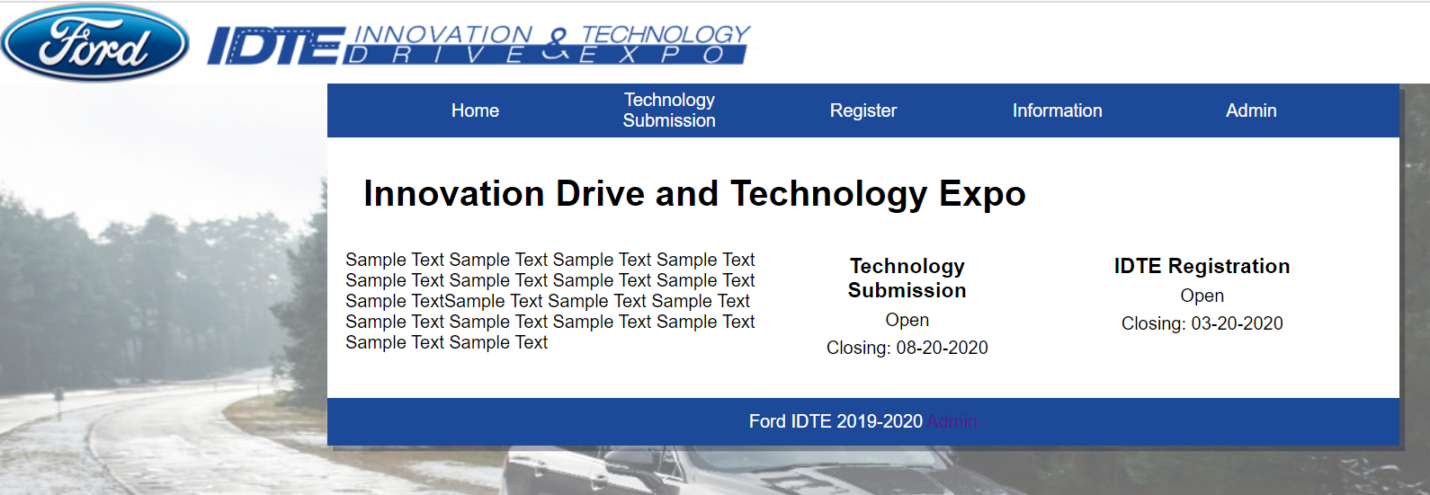

Homepage as Admin

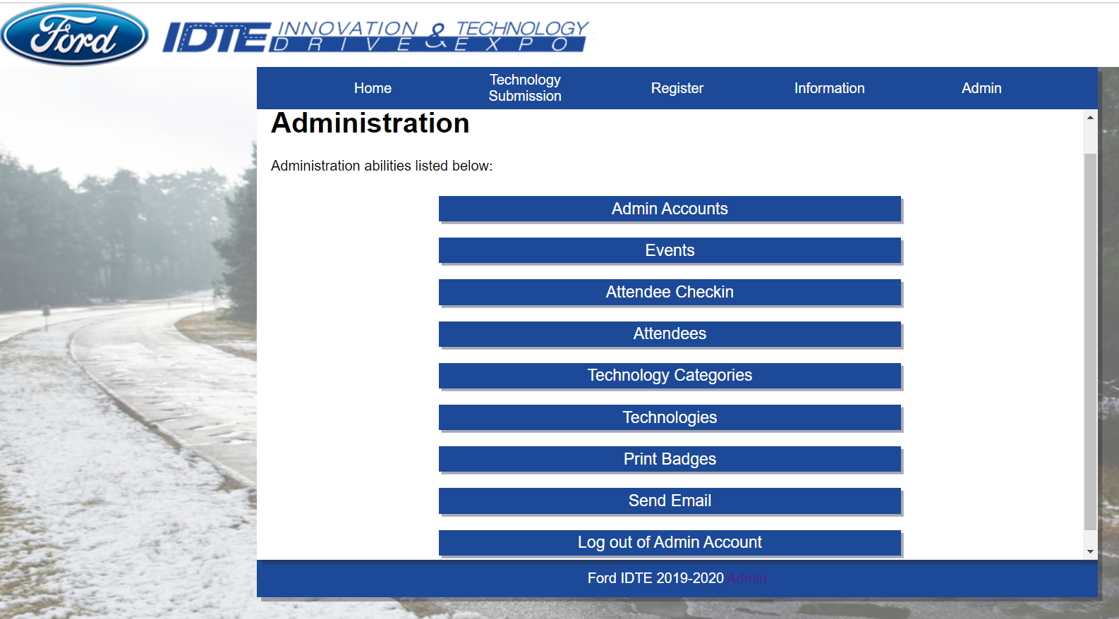

Administration Page

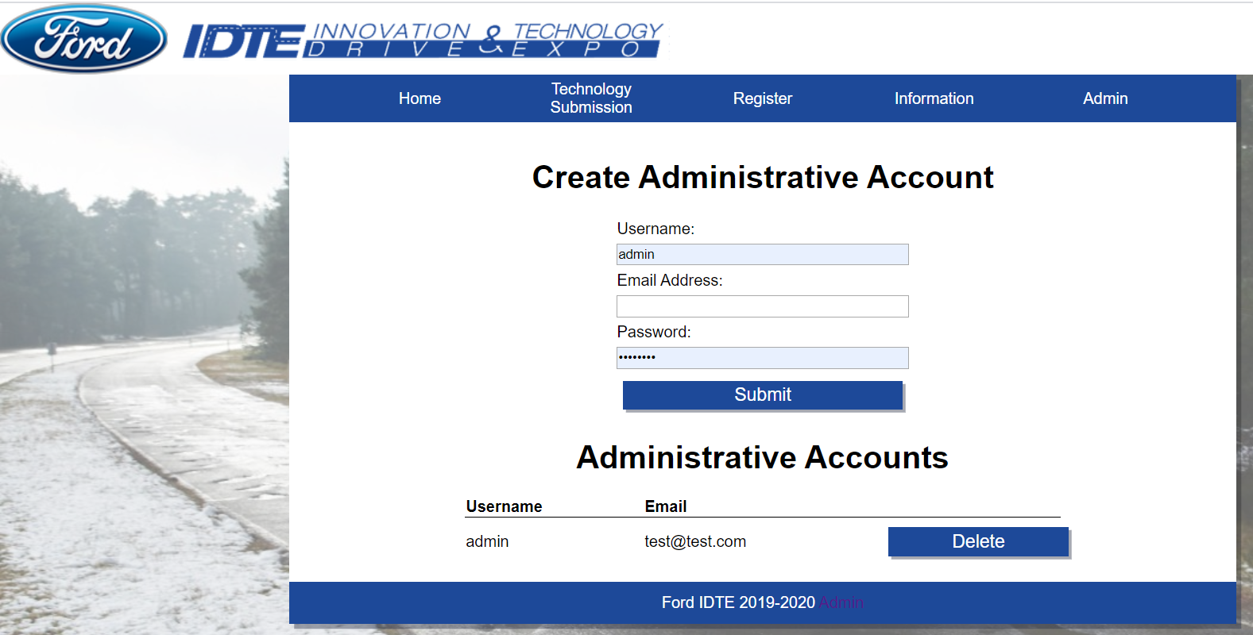

Admin Account Page

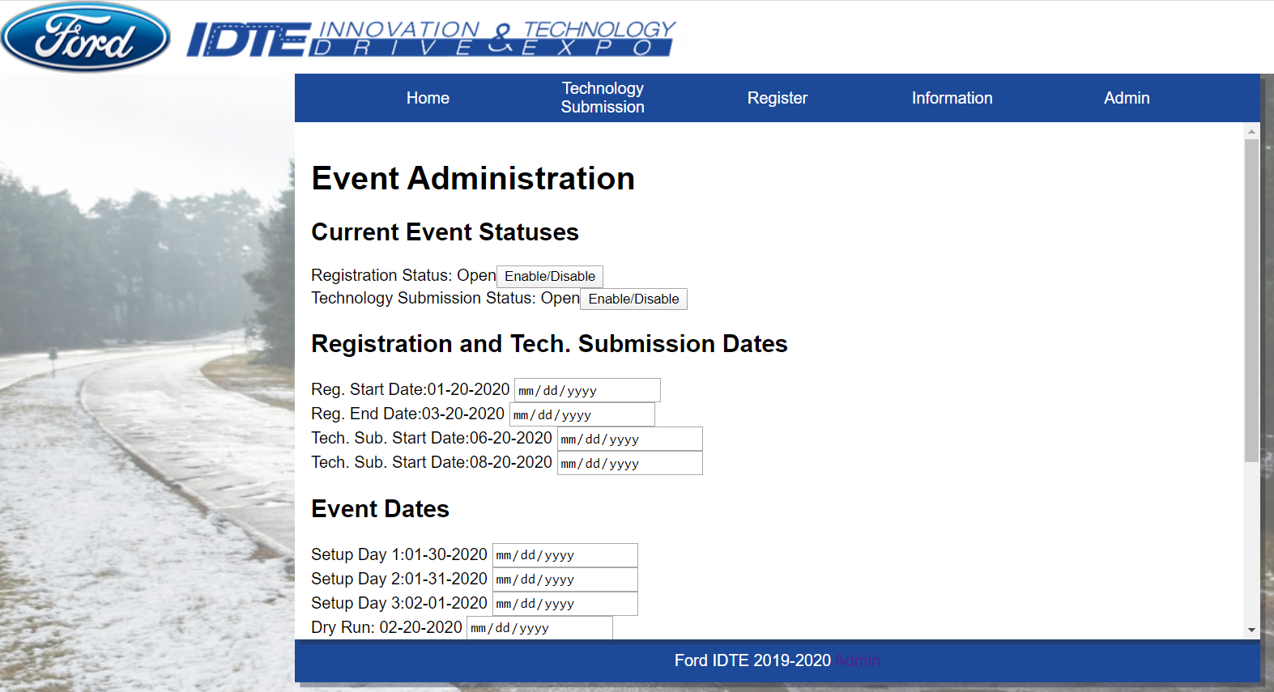

Event Administration Page (Edit Current Event)

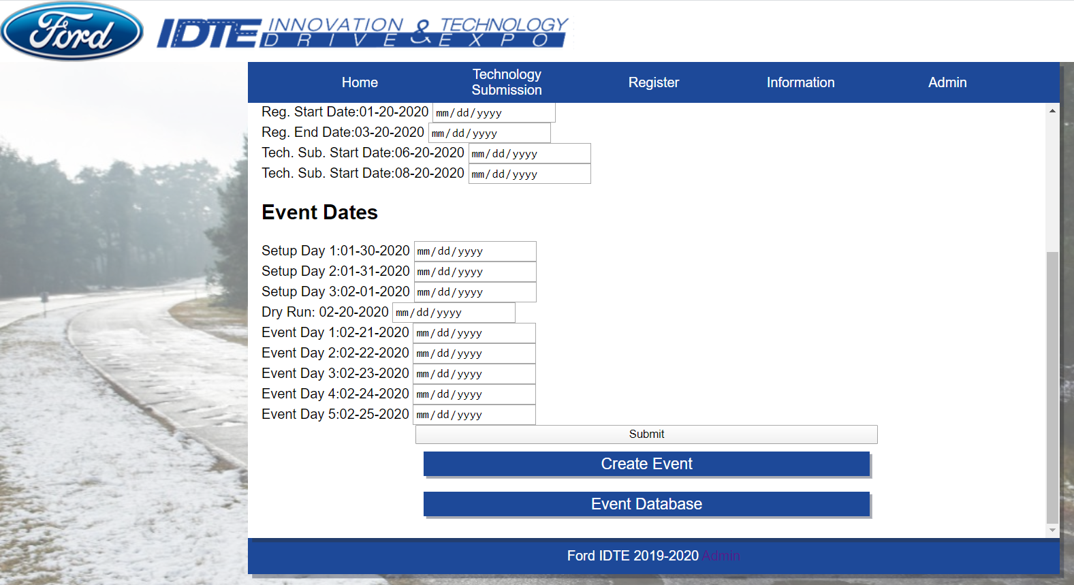Event Administration Page (Edit Current Event) continued

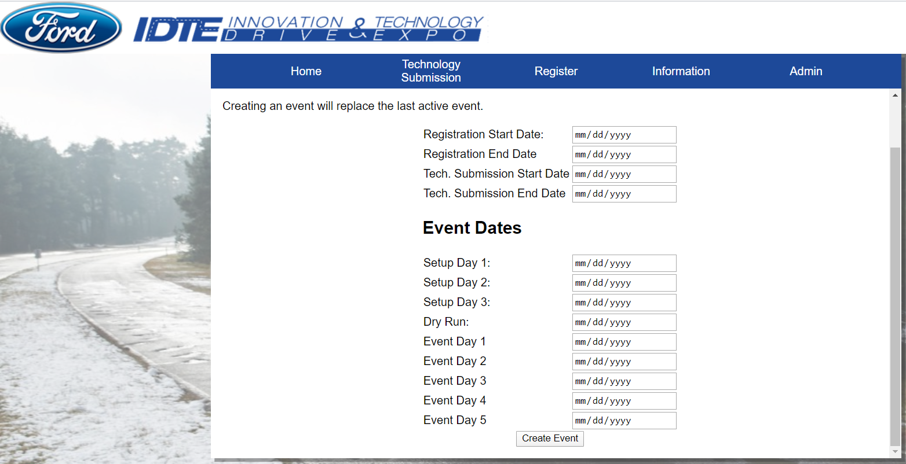

Event Administration Page (Create new event)

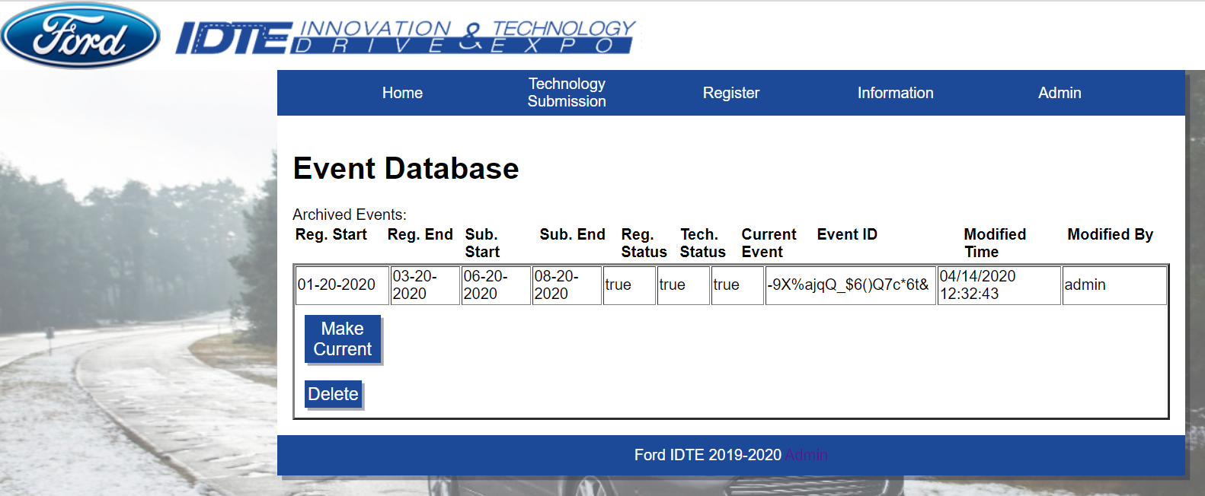

Event Database page

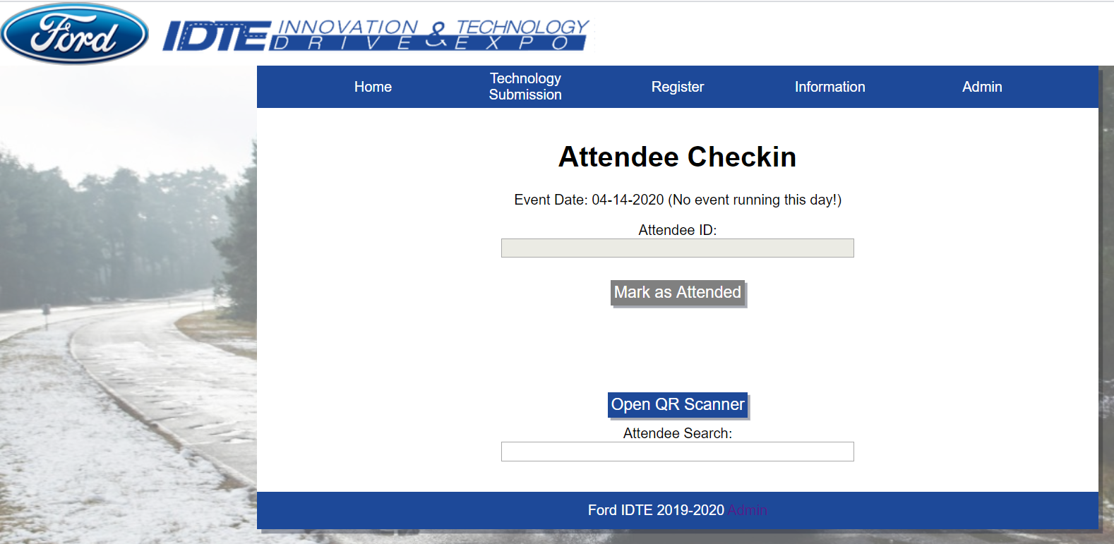

Attendee Checkin page

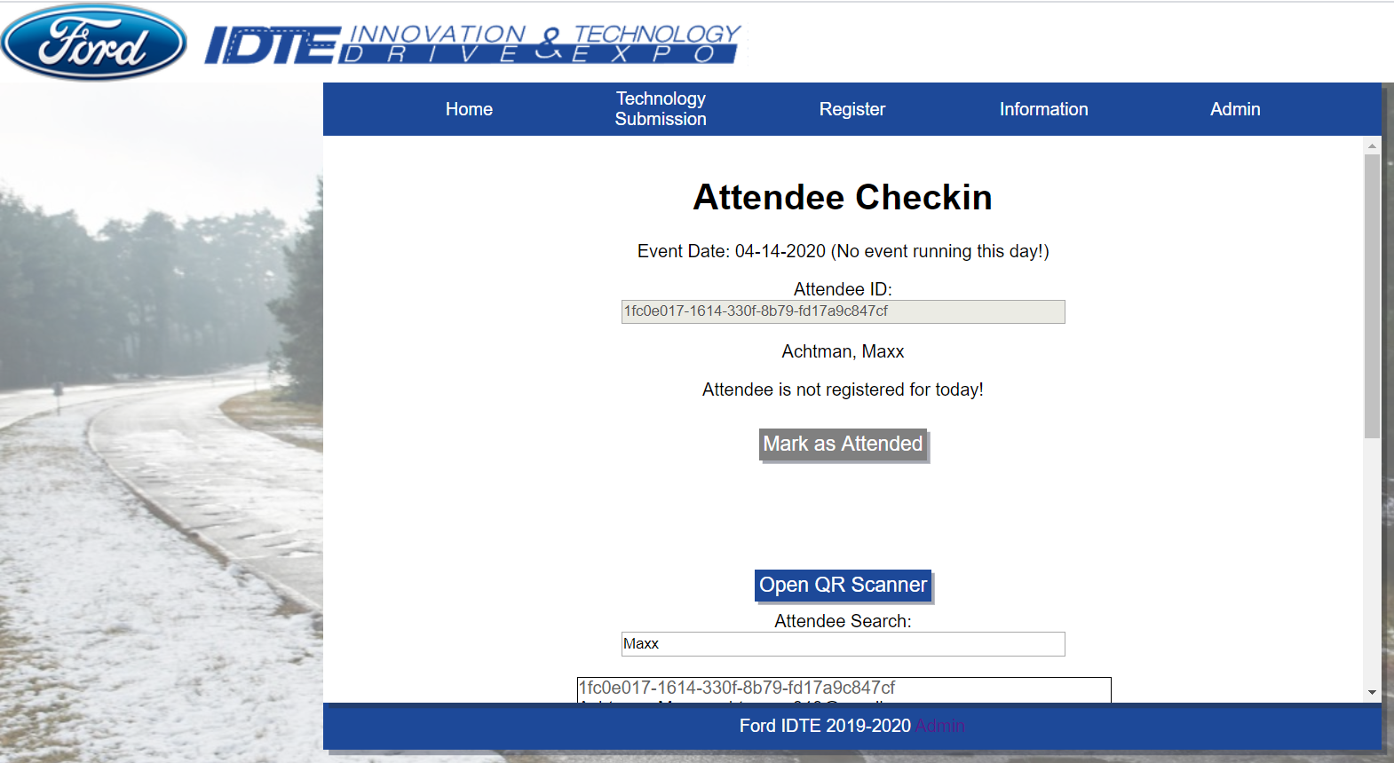

Attendee ID is populated on date that they should not be there

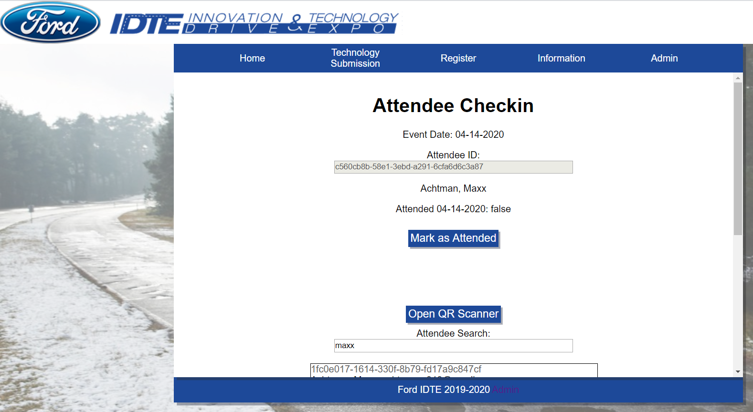

Attendee ID is populated on the date that they should be there. Before selecting “Mark as Attended”

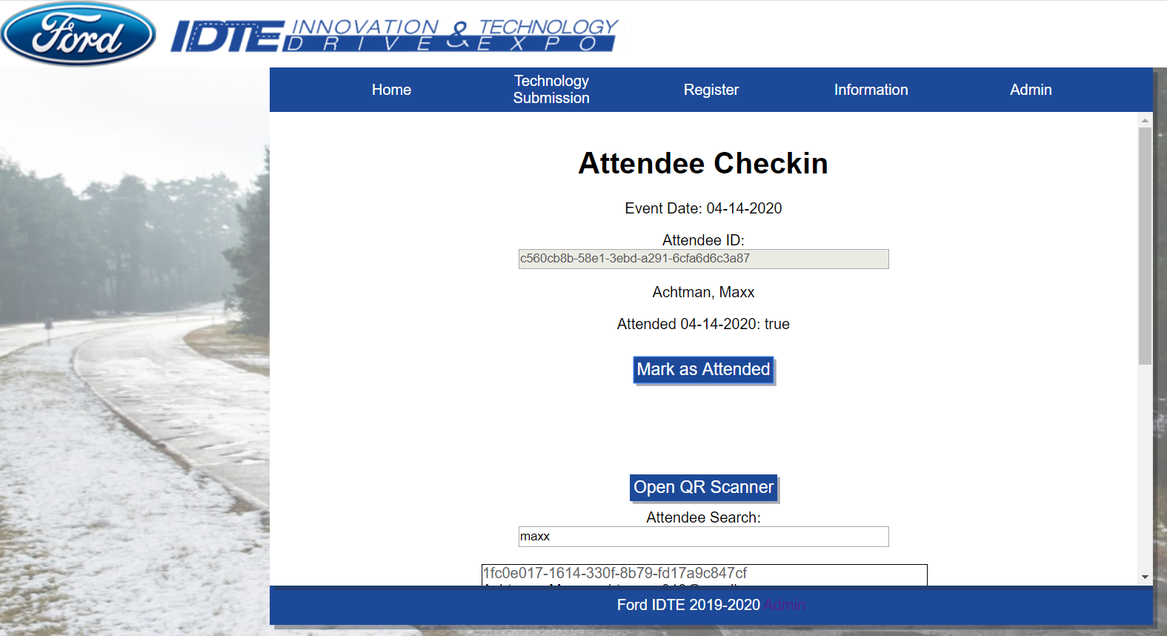

Attendee ID is populated on the date that they should be there. After selecting “Mark as Attended”

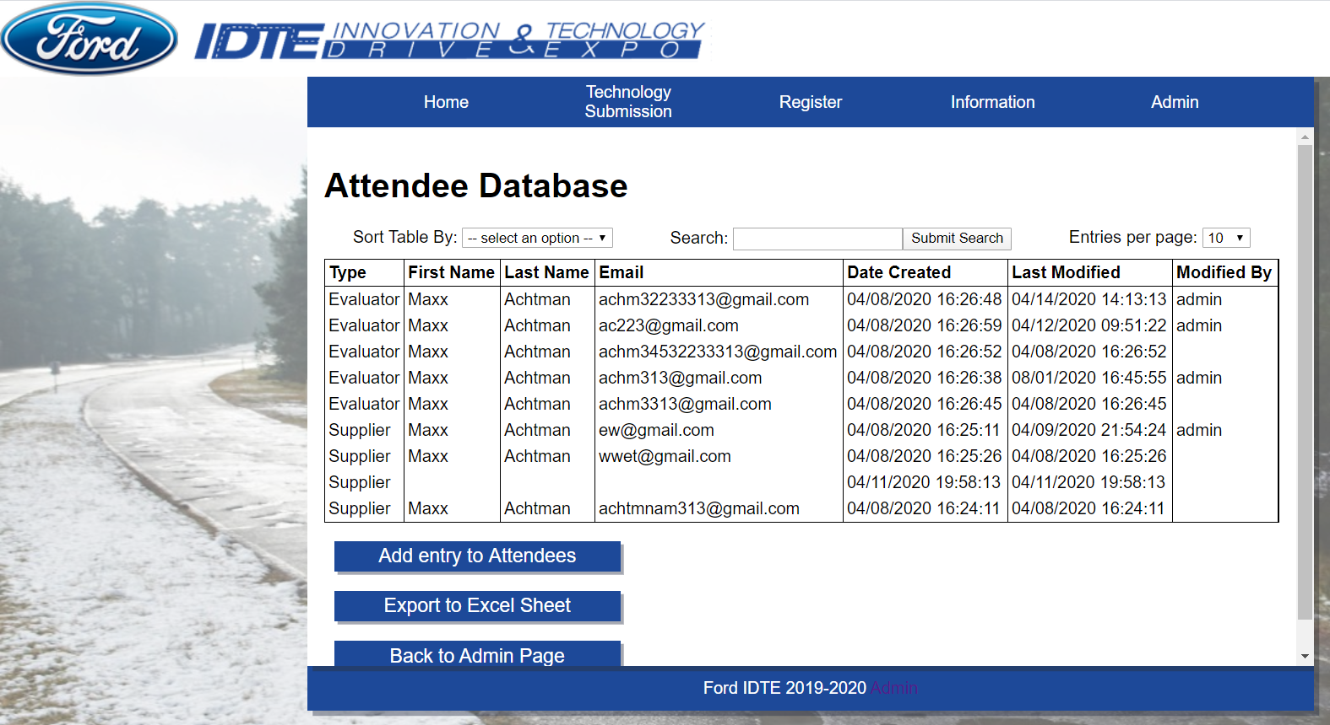

Attendee Database

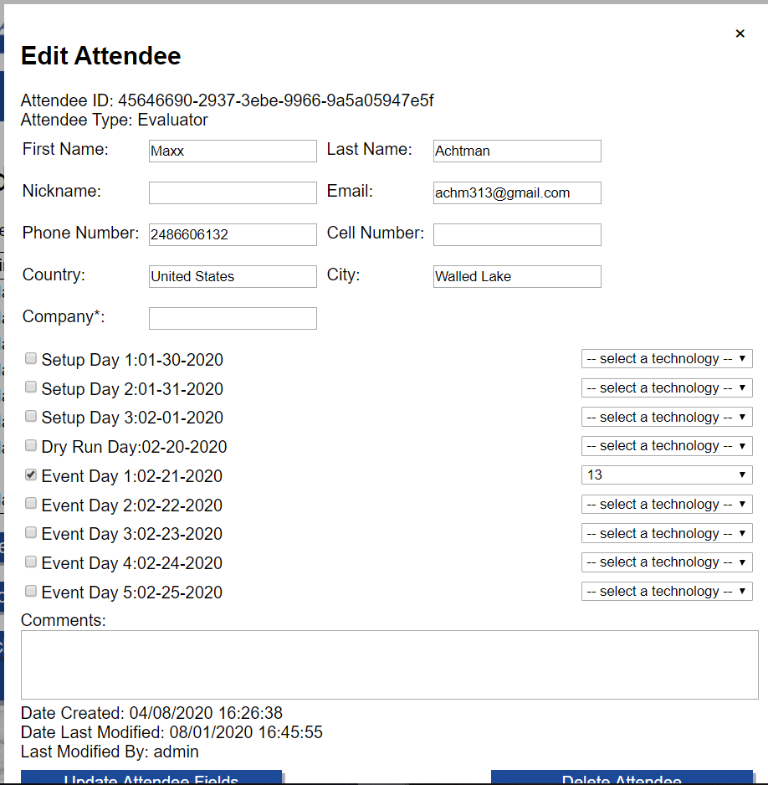Editing Attendee from Attendee Database

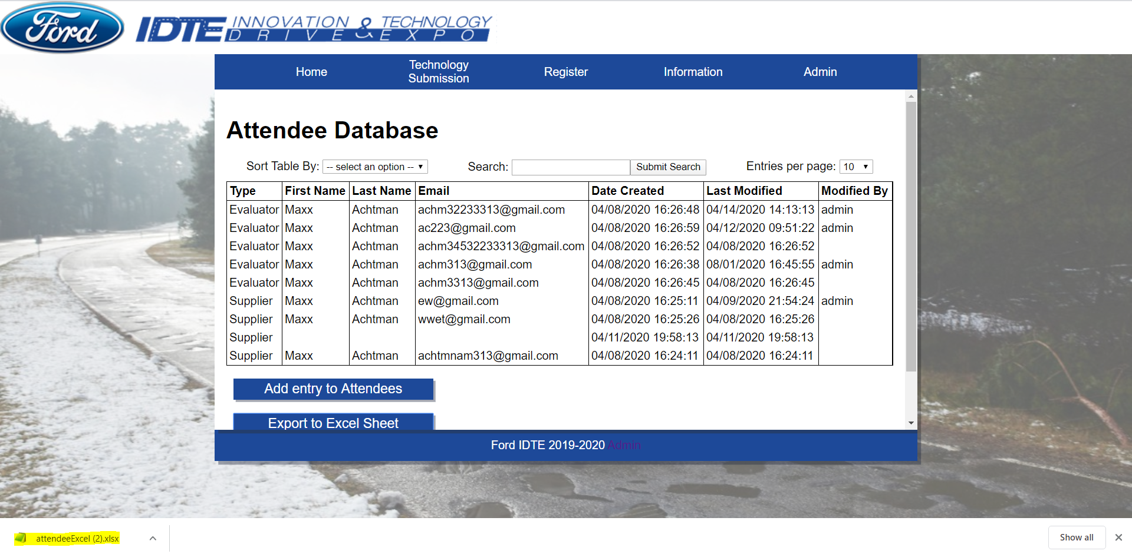

Export Attendee database to excel

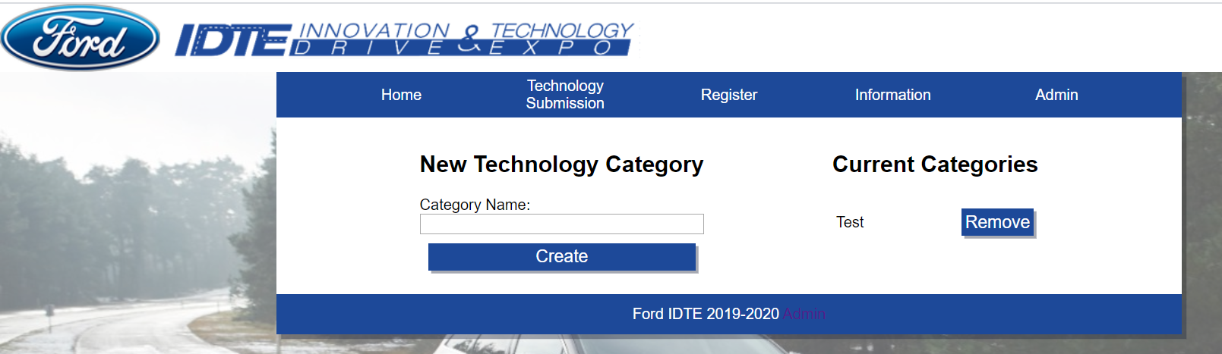

Technology Categories page

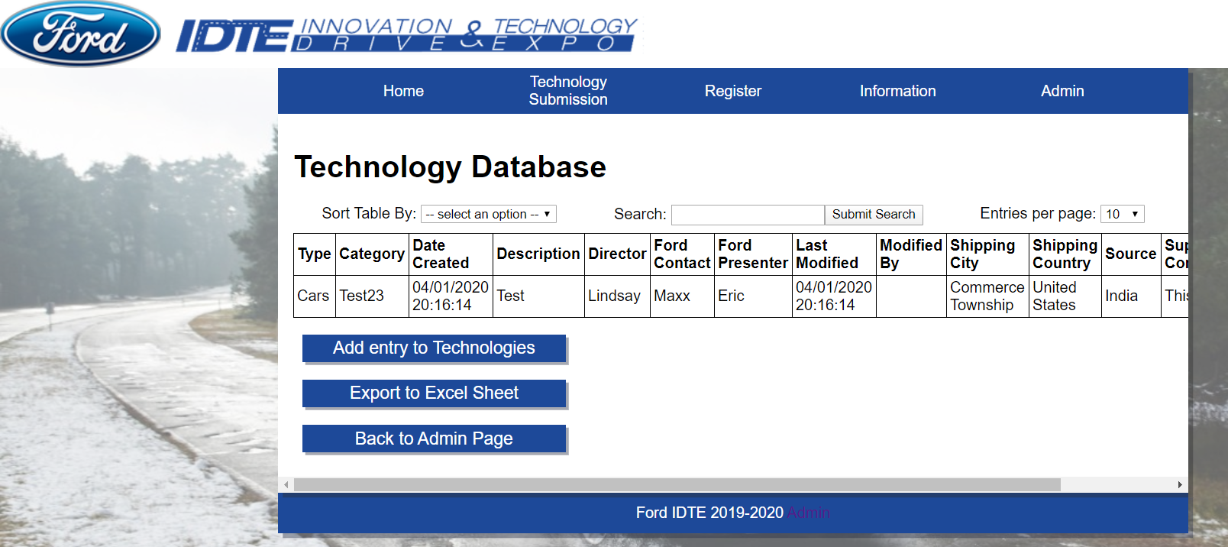

Technology Database

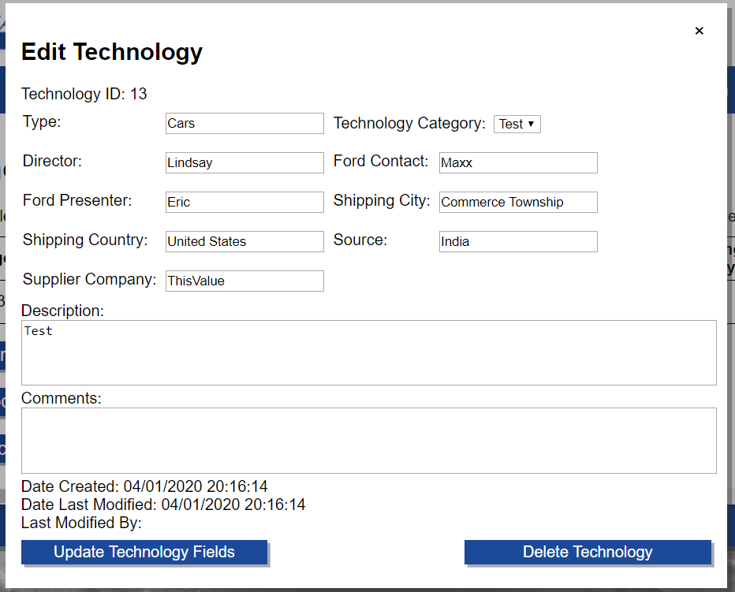

Edit Technology in Technology Database

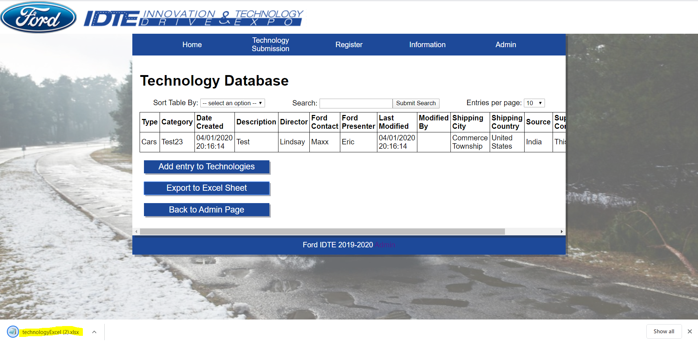

Export Technology Database to excel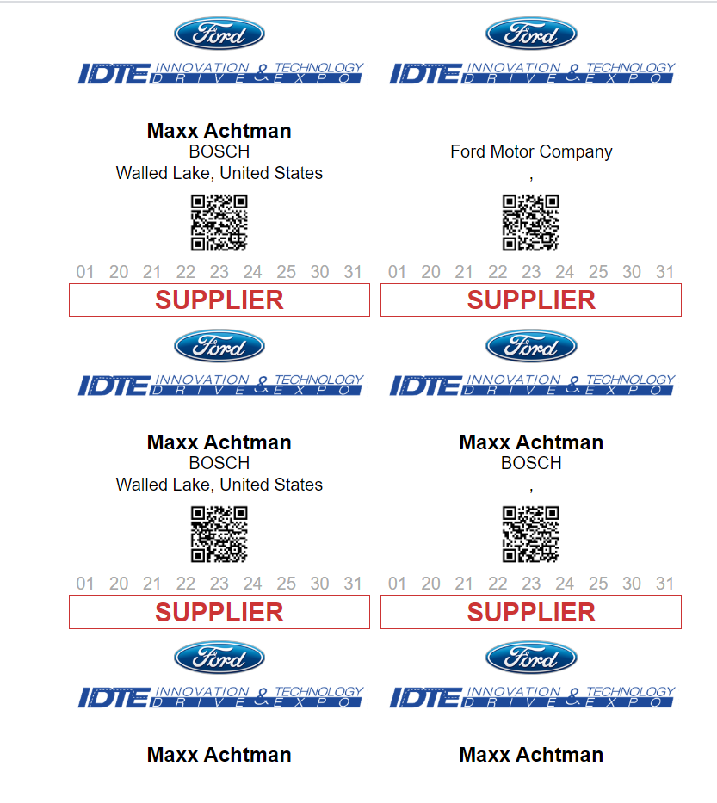

Badge Print Out

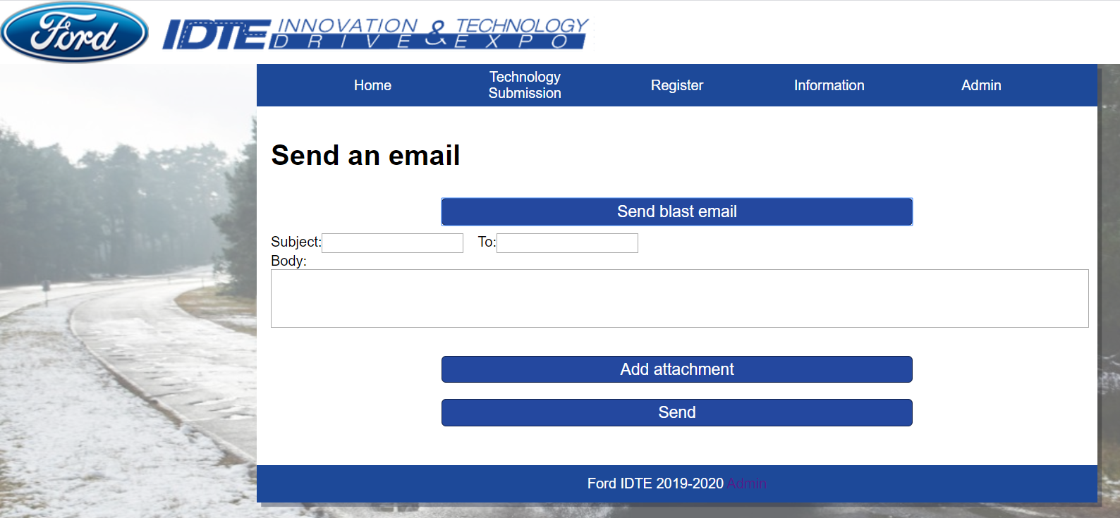

Send Email

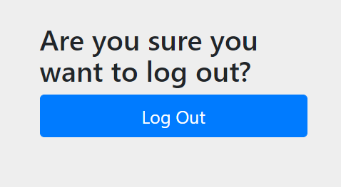

Logging out of Admin control

# Appendix C

## Project Plan

### Project Estimates

#### Historical Data Used for estimates

* School Projects
* Work Projects
* Vacation Time
* Weather Conditions
* School Scheduling
* Work Scheduling
* Meetings with client
* SLOC/FP Data from qsm.com
* FP calculator from University of Southern California

#### Estimation Techniques Applied and Results

* + - * 1. PMP Completion Estimation
* 100 Hours

##### Overall Project Estimation

Line-of Code Estimate

* 6527 SLOC average

Function Estimate

* 184 Function Points

##### Total overall project time estimate in hours of effort

* Effort: 24.524 person-months
* ~3923 hours
* Per person:
* 6.131 person months, 980.75 hours

#### Estimation techniques applied and results

##### Estimation Technique 1 - Lines of Code

* Several components to track, including:
* Front end React code, ~100 LOC/page, ~50 LOC/React Component. Estimated ~25 webpages, ~10 React components.  
    
  Front end estimation = 100*25 + 50*10 = 3000 LOC
* Server end Nodejs Code, ~30 LOC/CRUD operation, ~150 LOC/database object, ~200 LOC session management, ~200 LOC validation, ~12 CRUD ops, ~3 database objects  
    
  Server side estimation = 30 * 12 + 150 * 3 + 200 + 200 = 1210 LOC
* Configuration files for node, babel, and webpack, ~100 LOC NPM config, ~150 LOC webpack config, ~20 LOC babel config  
    
  Configuration estimation = 100 + 150 + 20 = 270 LOC
* Database SQL scripts, ~70 LOC user table, ~40 LOC technology table  
    
  Database estimation = 70 + 40 = 110 LOC

##### Estimation for Technique 1 - Lines of Code

* Total estimation is as follows:  
    
  Front end + server end + configuration + database scripts  
  3000 LOC + 1210 LOC + 270 LOC + 110 LOC  
    
  Final Estimation = 4590 LOC

##### Estimation Technique 2 - Function Points

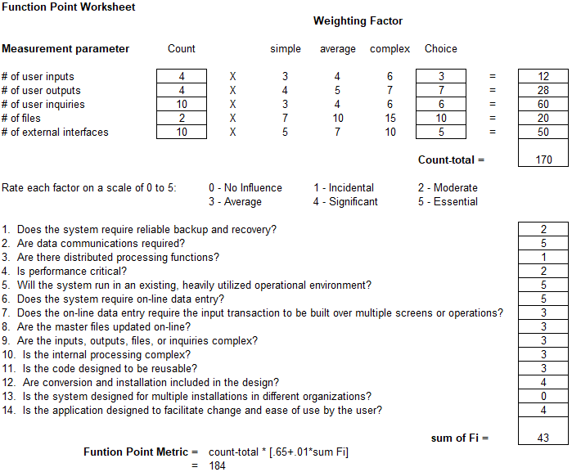

* Total amount of function points calculated using calculator created by University of Southern California

##### Estimate of Technique 2 - Function Points

* Total number of SLOC using function points and JavaScript as a reference according to QSM resources, is as follows:  
    
  184 * 46 = 8464

##### Estimation technique 3 - COCOMO

* To recap, a component evaluation of SLOC resulted in an estimated 4590 SLOC
* A function point evaluation for SLOC resulted in an estimated 8464 SLOC
* Don’t reconcile well, average is 6527 SLOC
* COCOMO equation is as follows: $E = a(KLOC)^{b}$
* E is the resulting effort required in person-months, a is 3.0 for semi detached, and b is 1.12. KLOC is the line of code total in thousands.
* COCOMO result for LOC evaluation -> E = 16.536
* Result for FP evaluation -> E = 32.809
* Average evaluation -> E = 24.524
* We will continue with the average evaluation

##### Estimate for Technique 3 - Final

* Average COCOMO evaluation for effort required was 24.524 person-months
* With a 4 man team, that is 6.131 Months Required for scheduling
* Wage per person at $75/hour over 6.131 months results in $73,572 per person
* 4 people on team, total cost from wages is $294,288

#### Project Resources

##### People

Contacts at Ford to help with verification and deployment to Ford servers

##### Hardware

(Potentially) SuSE server at Ford for development deployment and final production deployment

##### Software

VSCode for text editing

Nodejs for server side scripting

Reactjs/Angularjs for client side rendering and routing

NPM for package management and development scripts

Babel7 for ES6 JavaScript compilation

Webpack for creating deployment ready assets

Windows/MAC operating systems for developing on

SuSE operating system for deployment

WebSphere WAS for deployment

##### Tools

Personal computers and laptops for development

#### Budget Estimation

* + - * 1. As pulled from 2.3.6, it will cost the project $294,288 for completion of project in allotted time

Note: we are excluding production costs such as databases and servers

### Risk Management

#### Project Risks

* Poor Estimation on functionalities added during project creation
* Poor Estimation on Main Functionality
* Project Specifications changes
* Underestimation of Program Complexity
* Absence of Team Leader
* Absence of Other Team Members
* Inclement Weather
* Appearance of new technologies needed for functionalities
* Absence of Client

#### Risk Table

|  |  |  |  |  |
| --- | --- | --- | --- | --- |
| Risk | Probability | Impact | Mitigation Plan | Contingency Plan |
| Poor Estimation on Functionalities added during project creation | Medium | Low | Get regular updates and design main functionality to not rely on any additional functionalities | Drop support and expectations for respectable additional functionalities |
| Poor Estimation on Main Functionality | Medium | High | Get regular updates from team members to gauge progress, re-evaluate estimations regularly | Drop additional functionalities and focus on main |
| Project Specification changes | High | Medium | Focus on designing the project instead of programming it, design components modularly so if something changes the whole project doesn’t have to be redone | Change components that are affected by specification change |
| Underestimation of program complexity | Medium | Medium | Keep program functionality simple, have algorithms planned before creation of code | Reduce or remove functionality causing problems |
| Absence of Team Leader | Low | Medium | Finish Planning as early as possible, stay in contact | Assign new team leader and work off of what we have |
| Absence of Other Team Members | Low | Medium | Communicate regularly | Pick up the slack from other team members if items start falling behind |
| Inclement weather | Medium | Low | Adhere to schedule | Attempt digital meeting |
| Appearance of new technologies needed for functionalities | Medium | Medium | Attempt to learn early | Redesign plan to omit new technologies |
| Absence of Client | Low | Medium | Communicate regularly with client and raise questions immediately | Continue to focus on tasks that we know of for the project and wait until more news is brought up form the client |

#### Overview of Risk Mitigation, Monitoring, Management

|  |  |  |  |  |  |
| --- | --- | --- | --- | --- | --- |
|  | Impact | | | | |
| Probability |  | Low | Medium | High | Critical |
| Low |  |  |  |  |
| Medium |  |  |  |  |
| High |  |  |  |  |
| Legend | | | | | |
| Monitor | | Execute Mitigation Plan | | Execute Contingency Plan | |

* Re-evaluate risks once every one-two weeks

### Project Schedule

#### Project Task Set

|  |  |  |  |  |  |  |  |
| --- | --- | --- | --- | --- | --- | --- | --- |
| Task | Time  (Weeks) | Predecessor Tasks | Successor Tasks | Start Date (ES) | End Date (EF) | Slack Time | % Complete |
| SPMP | 1 |  | Develop Hello world | 1 | 2 | 0 | %100 |
| Develop Hello World | 1 | SPMP | Websphere Node Integration | 2 | 3 | 0 | %100 |
| Websphere Node.js integration | 4 | Hello world | Testing | 3 | 7 | 2 | %100 |
| Front End Home page | 1 | Hello world | Front End Tech Submission | 7 | 8 | 0 | %100 |
| Front End - Registration | 1 | Hello world | Back End - Registration | 7 | 8 | 2 | %100 |
| Front End - Technology submission | 1 | Hello world | Back End - Technology submission | 8 | 9 | 4 | %100 |
| Front End - Information | 1 | Websphere  Integration | Testing | 9 | 10 | 0 | %100 |
| Front End - Admin Actions | 1 | Hello world | Front End - Admin Actions | 10 | 11 | 5 | %100 |
| Back End - Registration | 3 | Front End - Registration | Testing | 10 | 13 | 0 | %100 |
| Back End - Technology submission | 3 | Front End - Technology submission | Testing | 13 | 16 | 0 | %100 |
| Back End - Admin Actions | 3 | Front End - Admin Actions | Testing | 16 | 19 | 3 | %100 |
| Database Design | 1 | SPMP | Database Creation | 2 | 3 | 3 | %100 |
| Database Creation | 2 | Database Design | Database Integration | 6 | 10 | 9 | %100 |
| Database  Integration | 3 | Database Creation  Back end registration | Testing | 19 | 21 | 0 | %100 |
| Testing | 4 | All Back end tasks | Deploy | 21 | 25 | 0 | %100 |

#### Functional Decomposition

A functional breakdown to be used for scheduling is presented here.

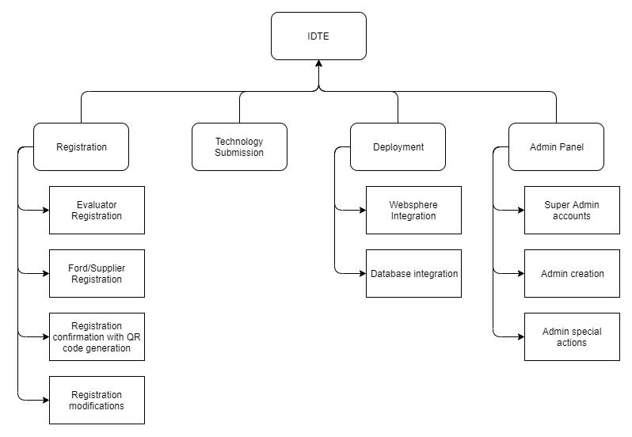

#### Task Network Diagram

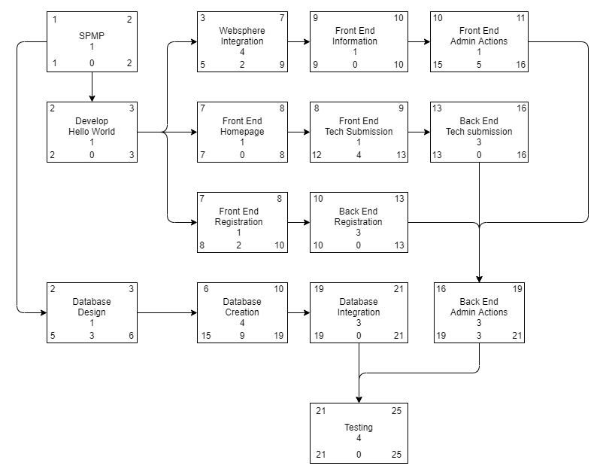

#### Timeline Chart

##### Project Schedule

### Staff Organization

#### Team Structure

* Maxx Achtman
  + Team Lead
  + Tester
  + Spokesperson
  + Diagram Designer
* Christopher Ciolek
  + Coordination
  + Programming
  + Bookkeeping
* Apolonio Cazares
  + Analysis
  + Programming
  + Backend Design
* Nicholas Spencer
  + Programming
  + UI Design
  + Document Re-visioning

*changes may be made during project life cycle

## Log Book

* + 1. November 20, 2019
       1. Added built React files to repo
    2. November 26, 2019
       1. Added testing components with Tomcat
    3. November 27, 2019
       1. Restructured Project
       2. Fixed gitignore
       3. Took node modules out of remote repo
       4. Fully fixed gitignore
       5. Removed conflicted file
    4. November 28, 2019
       1. Added multi page support
    5. December 1, 2019
       1. Started repositories for both evaluator and supplier
    6. December 2, 2019
       1. Switched all navlinks to html links
       2. Added registration.jsx
       3. Added registerwaiver.jsx
    7. December 3, 2019
       1. Implemented posting to database
       2. Created component for each page
       3. Replaced navlinks with html links
       4. Fixed information page links
       5. Implemented updating attendees to database
       6. Slight refactoring
       7. Made updating actually save changes
       8. Implemented deleting attendees from database
       9. Changed get by email to check json for email and id
    8. December 4, 2019
       1. REfactoring before adding technology rest controller
       2. Fixed delete path mapping
       3. Added technology.java
    9. December 10, 2019
       1. Started implementing technology controller
    10. December 15, 2019
        1. Merge branch ‘frontend’ to ‘master’
        2. Merged backend and frontend
        3. Fixed security issue in dependency
    11. December 31, 2019
        1. Finished frontend admin page
    12. January 31, 2020
        1. Started work on administrative database page
    13. February 1, 2020
        1. Made table component with resizable tables
    14. February 2, 2020
        1. Added modal to edit attendees from DB table
    15. February 4, 2020
        1. Made easier to use AJAX methods
    16. February 6, 2020
        1. Fixed issue with setting comments when creating new attendees
        2. Added functionality to add attendee button
        3. Added basic error handling to requests
        4. Updating and deleting users from the database interface implemented
    17. February 7, 2020
        1. Added pagination to database interface
    18. February 10, 2020
        1. Fixed bugged when having less attendees than rows per page
    19. February 12, 2020
        1. Updated pagination
        2. Fixed tiny merge conflict
        3. Fixed errant text from git extension
    20. February 13, 2020
        1. Fixed double background
        2. Added sorting to database interface
        3. Removed unnecessary todos
    21. February 16, 2020
        1. Integrated requests from 2/12 meeting
    22. February 18, 2020
        1. Started working on attendee database search
        2. Finished attendee database search
        3. Small code cleanup
    23. February 19, 2020
        1. Added admin email functionality
        2. Added backend support for technology categories
        3. Merge branch ‘frontend’ to ‘master’
        4. Updated application properties
        5. Updated pom xml
        6. Updated webpack config
    24. March 6, 2020
        1. Merge branch ‘newstyles’ to ‘master’
    25. March 9, 2020
        1. Added in event system
        2. Event system created and current WIP
        3. Changed Event pages
    26. March 10, 2020
        1. Started technology category implementation
        2. Merge ‘master’ into ‘frontend’
        3. Update readme for new instructions
    27. March 13, 2020
        1. Added functionality to buttons in Event
        2. Implemented email functionality for .jpg and.png files
    28. March 15, 2020
        1. Fixed email merge conflict
    29. March 16, 2020
        1. Main event functionalities
        2. Removed axios
    30. March 17, 2020
        1. Finished Events
        2. Created QR code generation
        3. Added Admin functionality
        4. Added Role functionality
        5. Removed unused imports
    31. March 18, 2020
        1. Storing technologies in database
        2. Admin login
        3. Fixed dependency on merge conflict
        4. Protected page links to admin pages
        5. Can create admin accounts
        6. Client side admin validation done
        7. Added TODOs for protecting admin routes
    32. March 19, 2020
        1. Added support for anonymous sessions
        2. Added logout
        3. Only admins can see admin tab on nav bar
        4. Added logout button for admins
        5. Finished admin accounts page
        6. Updated QR code functionality to read QR codes
    33. Match 22, 2020
        1. Added attachment file compatibilities for most types that gmail allows
        2. Navbar no longer goes to technology waiver, goes straight to form
    34. March 23, 2020
        1. Fixed technology submission
        2. Refactored tech for
        3. Made navbar to not show registration or technology if they are not enabled
    35. March 24, 2020
        1. Reformat Java code
        2. Update dates of current event
        3. Added base for attendee registration
        4. Made email page more reactive when sending emails
        5. Added days of physical event for admin to set
    36. March 25, 2020
        1. Event dates can be edited
    37. March 26, 2020
        1. Implemented registration
    38. March 31, 2020
        1. Updated QRCode to add Attendee ID
        2. Add support for new datastring format in attendee database
        3. Fixed bug in presenter/evaluator registration
        4. Updated QR Code Controller class
    39. April 1, 2020
        1. Added Webcam in QRSign in page
    40. April 2, 2020
        1. Implemented email confirmations upon registration
        2. Added QRSign in page UI
        3. Added technology submission registration
        4. Added thank you page for registration
        5. Added thank you page for technology submission
        6. Added agree checkbox to user waiver
    41. April 5, 2020
        1. Fixed event JSON format
    42. April 6, 2020
        1. New attendee data is working in registration
        2. Attendee database interface updated for new date storage
    43. April 7, 2020
        1. Added export to excel functionality for Attendee Database
        2. Added export to excel functionality for Technology Database
        3. Added email functionality to registration route
        4. Fixed bugs in technology submission
        5. Fixed bugs in email functionality
    44. April 8, 2020
        1. Added email functionality into technology submission
        2. Added badge printing functionality
        3. Fixed badges getting cut off when printing
    45. April 9, 2020
        1. Moved email functionality to threads
        2. Added styling to make mobile look less bad
        3. Added blast functionality to administrative emailing
        4. Added checkin
        5. Added search functionality in Technology Database
    46. April 10, 2020
        1. Bumped up resolution on generated QR codes for more consistent reading
        2. More mobile formating
        3. Fixed blast emails
        4. Changed header names
    47. April 11, 2020
        1. Fixed bug with carrying over registration type to registration form
        2. Update registration form to comply with specifications
        3. Fixed double buttons
    48. April 12, 2020
        1. Various fixes according to QA
        2. Removed unused imports
    49. April 17, 2020
        1. Updated text fields on various pages
        2. Added an image into Event Map Layout
        3. Added Event Date Restriction
        4. Added tip on creating event page
    50. April 19, 2020
        1. Updated Event Database Layout
    51. April 20, 2020
        1. Merged frontend to master

# Appendix D - Project Demo

## Project Demo Link:

[Project Demo Video](https://drive.google.com/drive/u/0/folders/1PufnR7H6kKhfsmaCd46zxEFOKXyy4lpX)

## Notes

### Homepage (0:00-0:30)

Starting off the presentation, we are displaying our homepage. On the homepage, we are able to show the Technology and Registration end dates. As mentioned in the presentation, we are showing both now since it is a demo.

### Technology Submission Form (0:31-1:12)

This form is used to submit technologies that would be displayed at the event. Any technologies submitted here would be added to the Technology Database. All fields are required to be filled out. We also have error handling in this form to make sure no fields are missing. We did not show it in the demo, but after submitting a registration, the user would be shown a confirmation page.

### Registration page (1:13-1:42)

This view is used to select from one of three Registration types. The types are Supplier, Presenter, and Evaluator. Once a user makes their selection, they would be taken to the Digital Waiver page.

### Digital Waiver (1:43-1:59)

This page is used to have the person registering agree to the legal terms of the site. This can be updated to match the exact wording and phrasing for Ford. As of now it is set up as a sample view for testing purposes. The continue button is disabled until they select the checkbox acknowledging the terms and conditions.

### Supplier Registration (2:00-3:11)

In this registration view, any field that is needed will be shown with an asterisk next to them. As a supplier, they would have to select one of three Setup days, the dry run day, and an event day. All days of the event are associated with a technology number for selection. We did not show it in the demo, but after submitting a registration, the user would be shown a confirmation page.

### Presenter Registration (3:17-3:33)

Presenter registration is the same as the Supplier except for Company since they are automatically generated as Ford (this is done behind the scenes). The same requirements as Supplier are needed for presenters. We did not show it in the demo, but after submitting a registration, the user would be shown a confirmation page.

### Evaluator Registration (3:37-4:27)

Evaluators are the most different since they are stuck to one day. They must choose three technology categories that they wish to view. Please note, there is also a text field notifying the user that we cannot guarantee their top pick for technology category.

### IDTE Information Tab (4:28-5:02)

Information tab is shown and each information area is reliable on Ford’s input. Right now they are all placeholders, however we have provided Ford the necessary steps in the User Manual to edit these fields along with the homepage and Digital Waiver pages.

### Admin Login and Admin Page (5:03-5:20)

The admin page can only be accessed through the admin panel. This can only be noticeable once an admin is logged in. In the example, we used a login that already exists in our database, hence the login was successful. From there, we are now shown an Admin panel. This panel would only be visible when an admin is logged in.

### Create Admin Account (5:21-5:32)

This page is used to add more admins to the site. This can be done easily and also remove an admin just as easily. Only specific people should have access to this site.

### Events Page (5:35-7:20)

The Events page is one of the biggest functions of our site. Since this affects the entire site, there are multiple smaller functions within it. On the first page, it is editing the current Event settings. Selecting submit here would update the current Event setup. Selecting Create Event would create a new event setup that would be setup in the database. The final view would be the Event Database. Here we can change the current Event setup and delete an Event from the database to clear up space.

### Updating Technology and Registration from Nav bar (7:21-7:34)

Setting the Registration and Technology buttons to enabled would show them available on the Nav bar. If they are not enabled, they would not be available for selection in the Nav bar.

### Attendee Checkin (7:42-9:13)

Showing the Attendee Checkin page, on our example there is no webcam functionality currently shown since we do not have a working webcam. However, the behavior would act the same where we scan a QR code and the Attendee ID would be populated on the Attendee ID text field. If the attendee is supposed to be there on the given day, then they can be marked as attended.

### Attendee Database (9:24-10:43)

The Attendee Database houses all attendees that have already registered. We can allow sorting to occur by a manual input or using one of the values in the column headers from a drop down. Clicking on an attendee would allow them to be edited. It will show a timestamp when an attendee is modified. There is also an option to add a new attendee in this view. An admin could also export the database to an excel file.

### Technology Category (10:46-10:52)

This view is very simple. Adding a technology category and removing the technology category. Categories are needed when creating a technology since a technology would house one of 12 category types.

### Technology Database (10:56-11:10)

The Technology Database houses all technologies that have already registered. We can allow sorting to occur by a manual input or using one of the values in the column headers from a drop down. Clicking on a technology would allow them to be edited. It will show a timestamp when a technology is modified. There is also an option to add a new technology in this view. An admin could also export the database to an excel file.

### Print Badges (11:16-11:42)

This is an external printer friendly file created. Each badge would contain the person’s name, where they’re from, company, QR code, and dates of attendance. Color code to signify checkin. Supplier, Evaluator, and Presenter would have their own colors on the badges to signify differences.

### Send Emails (11:44-12:02)

Here, admins can send emails to individual users or in bulk by registration types. This would be used as reminders when the event gets closer.

### Logout of Admin Account (12:08-12:14)

Once an admin is done with their duties, they can sign out. Once sign out is completed, the admin panel is now hidden again.

# Appendix E - Final

## Link to the ppt for the Team Postmortem Presentation can be found here:

[**Team Postmortem Presentation**](https://docs.google.com/presentation/d/15lBIBsaTfIne-ten8pklqwlGoCttwm9S/edit?dls=true)